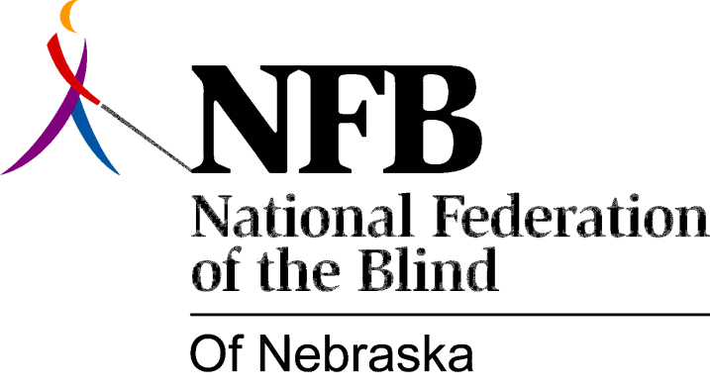

RESOLUTION 2008-01

RE: Proposed Amendment to Constitution of Nebraska.

WHEREAS, the National Federation of the Blind of Nebraska (NFBN) has long been the strongest voice advocating for the rights of the blind in Nebraska; and

WHEREAS, NFBN does not seek preferential treatment, but equal rights for the blind in education, employment and contracting; and

WHEREAS, NFBN firmly opposes any discriminatory practice by public or private entities; and

WHEREAS, the proposed Civil Rights Initiative, to appear on the November ballot, would amend Article I of the Constitution of Nebraska by adding a Section 30 as follows:

(1) The state shall not discriminate against, or grant preferential treatment to, any individual or group on the basis of race, sex, color, ethnicity, or national origin in the operation of public employment, public education, or public contracting."; and

WHEREAS, the proposed language, either by oversight or deliberate design, omits mention of disability; and

WHEREAS, the potential of this omission to open the door to unwanted preferential treatment and discrimination poses a clear and present danger to disabled persons, including the blind: Now, therefore,

BE IT RESOLVED by the National Federation of the Blind of Nebraska in Convention assembled this twelfth day of October, 2008, in the City of Grand Island, Nebraska, that we vehemently oppose amending the Constitution in a way that discriminates against the disabled in its very language; and

BE IT FURTHER RESOLVED that we communicate our opposition both to those who favor the so-called Civil Rights Initiative and others who oppose it; and

BE IT FURTHER RESOLVED that we communicate our concerns and opposition to organizations of disabled persons to warn them of the potential harm that can come from this proposed amendment.

