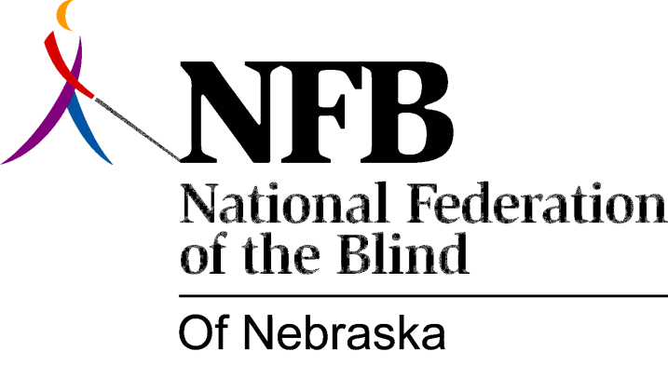

Resolution 2007-01
RE: Commending Senator Engel
Whereas, the largest and fastest-growing population of blind persons in Nebraska is the senior blind; and
Whereas, the Nebraska Commission for the Blind and Visually Impaired (NCBVI) does not have sufficient funds to provide adequate training to this large and ever-growing population of older blind; and
Whereas, the National Federation of the Blind of Nebraska (NFBN) strives to improve the lives of all blind persons; and
Whereas, the NFBN recognized this critical need and took the initiative to request additional funding from the Unicameral for this purpose; and
Whereas, Senator Pat Engel provided critical guidance and direction to our organization regarding the most effective manner in which to present our request; and
Whereas, Senator Engel not only provided this guidance but he also helped to persuade his colleagues on the Appropriations Committee to increase the budget for NCBVI in this vital area; and
Whereas, Senator Engel has demonstrated his friendship with the blind by repeatedly advocating for the budget of the Commission in previous years, especially during times when the economy was seriously challenged, and nearly every state agency received cuts to their funding; and
Whereas, we were successful in having the Unicameral give open-minded consideration to the Commission budget in spite of the reservations of senators regarding maintaining the Commission's budget at the levels necessary to provide adequate services; and
Whereas, Senator Engel fought alongside us like a fellow Federationist to maintain the budget of the Commission, and went on to assist us to increase the funding for providing additional services to the senior blind; and
Whereas, as a result, an "Older Blind Specialist" was hired as of October first of this year and has already begun to work diligently to deliver improved services to the senior blind of our state; Now, therefore,

be it resolved by the National Federation of the Blind of Nebraska in Convention assembled this sixth day of October, 2007, in the city of North Platte, Nebraska, that this organization hereby recognizes Senator Engel as a champion for all blind persons because of his ongoing efforts on our behalf in the Unicameral and commends his leadership, determination, dedication and perseverance this past session in partnering with the organized blind of Nebraska in achieving this milestone in services for our state's senior blind.

