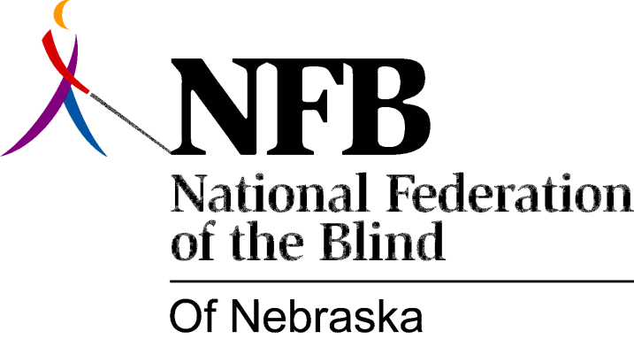

Resolution 2006 – 01
RE: Independent Living Programs for Blind Youth and Blind Seniors

WHEREAS, early intervention in the lives of blind children provides the best possible rehabilitation experience, AND,

WHEREAS, public school systems have many responsibilities toward children with disabilities and blindness training is only one among many, AND

WHEREAS, the Nebraska Commission for the Blind and Visually Impaired (NCBVI) possess comprehensive experience about blindness and also espouses a positive philosophy of blindness making it the states leading agency for working with blind individuals, AND,

WHEREAS, the federal government provides approximately 90% of its funding toward serving blind individuals between the age of 16 and 55 even though this demographic encompasses only 40% of blind individuals, AND,

WHEREAS, allocation of government funds currently serves 5% of the senior blind, AND,

WHEREAS, approximately 50% of blind individuals are over the age of 55 and it is estimated by the year 2010 1 in every 5 individuals above the age of 55 will be blind, AND,

WHEREAS, NCBVI does not possess sufficient funds to serve blind youth and the senior blind to the fullest extent, AND,

WHEREAS, the National Federation of the Blind of Nebraska is the State’s oldest and largest consumer organization of the blind making it the leading authority on all matters of blindness because of its collective experience and desire to improve the lives of all blind individuals, NOW THEREFORE,

BE IT RESOLVED, by the National Federation of the Blind of Nebraska in convention assembled this 15th day of October in the city of Omaha, NE, that the National Federation of the Blind of Nebraska call upon the Governor and the Unicameral to provide funding for an independent living program to assist blind youth from ages birth to 16 and the senior blind, AND,

BE IT FURTHER RESOLVED, that the National Federation of the Blind of Nebraska will work closely with NCBVI to produce programs which will implement effective training strategies for these individuals.

