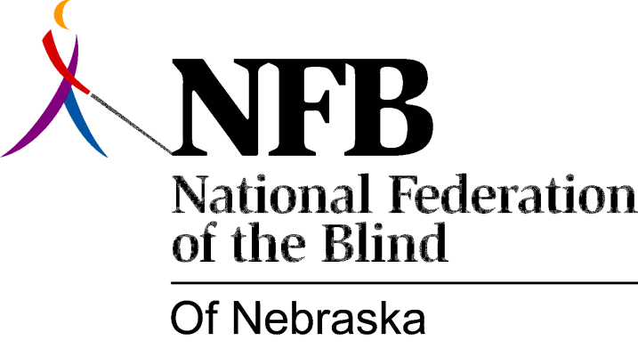

Resolution 1999-04

RE: Braille Textbook Production

WHEREAS, the National Federation of the Blind of Nebraska has long fought for the right of blind children to have an equal education; and

WHEREAS, an integral part of equal education for blind children is learning and using braille; and

WHEREAS, the State of Nebraska Department of Education has endorsed this position in its most recent revision of Rule 51; and

WHEREAS, for such a stance to be as meaningful as possible, texts in braille must be available; and

WHEREAS, production of texts in braille is currently both slow and iffy, causing uncertainties, interruptions, frustration and reduced achievement for blind students; and

WHEREAS, the states of Texas and California have passed laws requiring all producers of textbooks sold in those states to make their materials available in a format suitable for conversion into braille; Now, therefore,

BE IT RESOLVED by the National Federation of the Blind of Nebraska, in Convention assembled this ninth day of October, 1999, in the city of Scottsbluff, Nebraska, that this organization call upon the Nebraska Unicameral to enact appropriate legislation parallel to those laws, so that blind Nebraskans may receive textbooks in braille in a timely manner.

