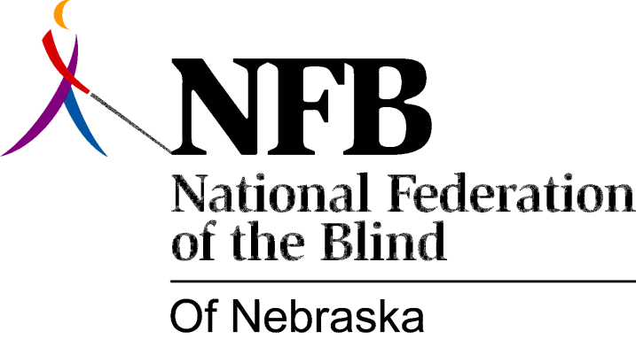

Resolution 1996-06

RE: State Program to Assist Employment of the Blind

Whereas, it has been the long standing policy of the National Federation of the Blind to promote economic security and competitive employment opportunities for the blind; and

Whereas, an existing federal employment program assists blind persons in obtaining employment within the federal government by providing temporary placements on a preferential basis; and

Whereas, this federal program has proven successful in creating jobs for the blind, many of which become permanent; now, therefore,

Be It Resolved, by the National Federation of the Blind of Nebraska, in convention assembled this 13th day of October 1996, in the city of Columbus Nebraska, that the National Federation of the Blind of Nebraska seek the adoption of legislation at the state level, similar to that currently providing employment opportunities for the blind at the federal level.

