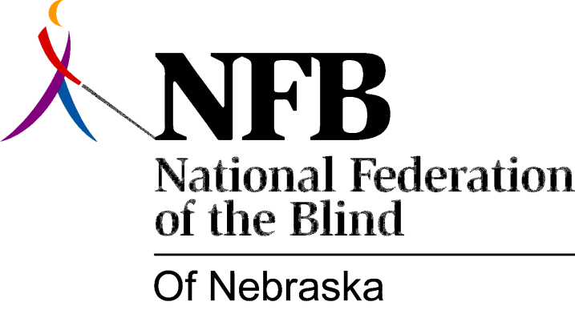

Resolution 1996-02

RE: Encouraging SVI to provide Administrative Leave for Any Staff Wishing to Attend a NFB National Convention

Whereas, The national convention of the National Federation of the Blind offers rehabilitation professionals the opportunity to participate in an unique and comprehensive continuing education program which includes: presentations from the Commissioner of the Rehabilitation Services Administration, the Director of the National Library Service for the Blind and Physically Handicapped and representatives from the Social Security Administration; networking opportunities with employers of blind persons and blind professionals employed at all levels of the private and public sector; demonstrations of the most current technological advances available to the blind and the chance to speak with technology vendors and service providers; and

Whereas, Rehabilitation professionals who have participated in national conventions of the National Federation of the Blind, find that the experience greatly assists them in the performance of their jobs by providing them with current information and contacts in the areas of vocational opportunities, technology and policy; and

Whereas, Services for the Visually Impaired currently grants administrative leave to only two (2) staff persons each year, for the purpose of attending the NFB national convention; and

Whereas, staff members receiving administrative leave to attend the national convention must and do cover all of their own expenses; and

Whereas, SVI staff members who wish to avail themselves of this exciting, comprehensive training opportunity and who are willing to incur the cost should receive administrative leave for this purpose without limitation on the number of persons eligible for such leave; and

Whereas, enabling SVI staff members wishing to participate in this and other training programs offering similar networking and educational opportunities, by providing them with administrative leave represents sound business practice consistent with the Rehabilitation Services Administration's emphasis on-going staff development; now, therefore,

Be It Resolved, by the National Federation of the Blind of Nebraska, in Convention assembled this 13th day of October, 1996, in the city of Columbus Nebraska, that we call upon the Director of Services for the Visually Impaired and the Department of Health and Human Services, to take any and all steps necessary to provide administrative leave to all SVI staff members wishing to attend the national convention of the National Federation of the Blind and other training and informational programs offered by similar organizations.

