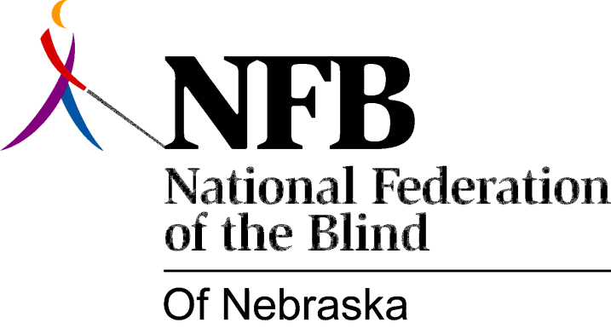

Resolution 1995-03

RE: Opposition to Audible Traffic Signals

Whereas, for the past two years, the city of Lincoln has had an audible traffic signal located at 11th and O streets in downtown Lincoln; and
Whereas, this signal is not necessary for blind travelers, and only serves to irritate the public, blind and sighted alike;and

Whereas, the city of Lincoln, in its wisdom and in response to the voice of the National Federation of the Blind of Nebraska, decided to remove this audible traffic signal; Now, therefore,

Be it resolved, by the National Federation of the Blind of Nebraska, in convention this 21st day of October, 1995, in the city of Grand Island, Nebraska, that we commend and applaud Mayor Mike Johanns and the city of Lincoln for removing this noisy, dangerous, and distracting device, making Lincoln a safer and more peaceful place in which to work and travel.

