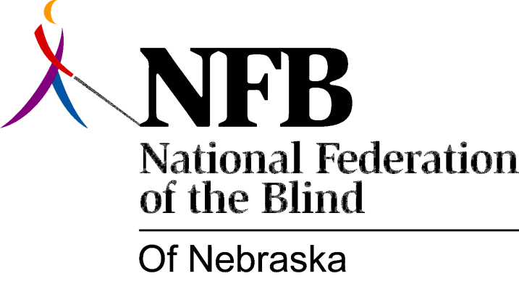

RESOLUTION 1993-05

RE: Support a Residential Option for the Education of Blind Children

WHEREAS; the National Federation of the Blind of Nebraska (NFBN) has long supported the concept of a residential school for the blind as an essential option for the education of blind children; and

WHEREAS; the existence of alternative education options, combined with the relatively small population base of Nebraska continues to diminish the numbers taking advantage of the residential option; and

WHEREAS; the changing characteristics of the student body at the Nebraska School for the Visually Handicapped (NSVH) together with increasing costs and decreasing numbers, greatly inflates the per pupil cost of education at NSVH; and

WHEREAS; the annual per pupil cost nearing $60,000 has become a matter of political concern and legislative inquiry; and

WHEREAS; NFBN cannot support the concept of consolidation with the Nebraska School for the Deaf as an alleged money saving strategy; now, therefore,

BE IT RESOLVED by the National Federation of the Blind of Nebraska in convention assembled this 17th day of October, 1993, in Columbus, Nebraska, that this organization urge the Nebraska Department of Education and the state legislature to explore meaningful alternatives for the education of blind children, including possible cooperation with neighboring states to establish regional schools to provide both a sound education program and appropriate training in the skills of blindness, with a view to the educational benefit rather that adopting solutions for the sake of fiscal constraints; and

BE IT FURTHER RESOLVED that this organization reaffirm its support of the concept of a residential option that is operated as part of an array of educational options and in a cost effective manner.

