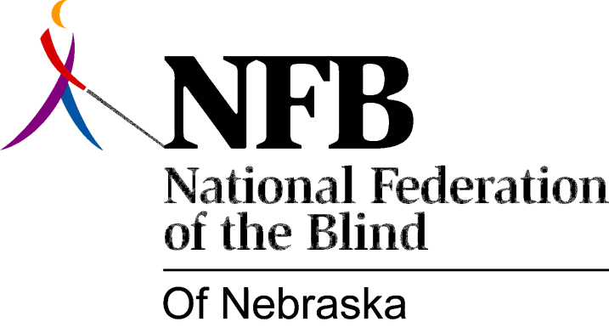

RESOLUTION 1993-01

RE: Braille Literacy Bill in Nebraska

WHEREAS; several states have passed legislation mandating Braille instruction for blind and visually impaired children in the schools as part of their Individual Education Program; and

WHEREAS; Braille literacy is essential to the future success of blind and visually impaired children; and

WHEREAS; the National Federation of the Blind of Nebraska supports literacy for all blind people and has a long history of promoting the use of Braille; now, therefore,

BE IT RESOLVED, by the National Federation of the Blind of Nebraska in convention assembled this 17th day of October, 1993 in the city of Columbus, that this organization work with the Nebraska legislature in introducing and supporting a Braille literacy bill in Nebraska.

