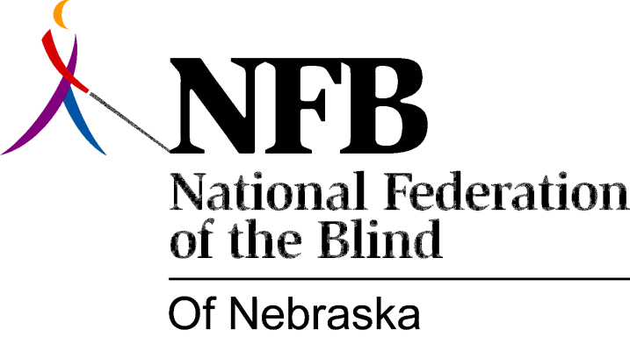

RESOLUTION 1991-01

RE: Removal of “Good and Evil” from ABC’s Weekly Television Schedule

WHEREAS, the American Broadcasting Company (ABC) is airing a new program titled “Good and Evil” which includes performances by an actor portraying a blind person; and

WHEREAS, the attitudes about blindness portrayed and expressed by this character and those having interaction with said character have been most disturbing to blind persons throughout the nation; and

WHEREAS, the production staff of this show has, through woeful ignorance and a true lack of understanding about blindness and the use of common sense, created a false and incorrect image to the public about the blind, and

WHEREAS, the National Federation of the Blind (NFB) has worked for more than 50 years to properly educate the public about blindness, and

WHEREAS, members of the NFB have proven that the blind can compete on terms of equality with the sighted, and that blindness is only a characteristic and a nuisance; and

WHEREAS, these positive views and values expressed by the NFB diametrically oppose the negative views and values depicted in this sitcom; and

WHEREAS, broadcasting of “Good and Evil” is contrary to ABCs own policy regarding the "elimination of negative stereotypes" *; and

WHEREAS, the producers of this program would not dare to attempt to humiliate other minorities such as blacks and Hispanics in such a demeaning, arrogant, crude, obnoxious, harmful and disrespectful fashion as has been done to the blind; and

WHEREAS, ABC has refused to consult with representatives of the NFB, the largest organization of the blind in this country, who have offered to provide assistance; now, therefore,

BE IT RESOLVED THAT the National Federation of the Blind of Nebraska assembled in convention this 6th day of October, 1991, that we call upon the President and other ranking executives of ABC with decision making powers to act in a responsible manner by immediately removing “Good and Evil” from its weekly program schedule; and

BE IT FURTHER RESOLVED THAT we condemn and deplore this sitcom and call upon ABC executives to offer a formal apology to the blind of this nation for airing such a distasteful program, whose main contention is to ridicule and insult the blind, rather than promote the positive accomplishments and attitudes of blind persons; and

BE IT FURTHER RESOLVED THAT ABC provide an opportunity to the leadership of the NFB to formally dispute and repudiate the harmful and discriminatory attitudes expressed in this program, through a vehicle such as 20/20, Nightline, and Primetime, thus allowing the NFB to properly and accurately express and describe abilities, capabilities and issues of concern facing the blind.

