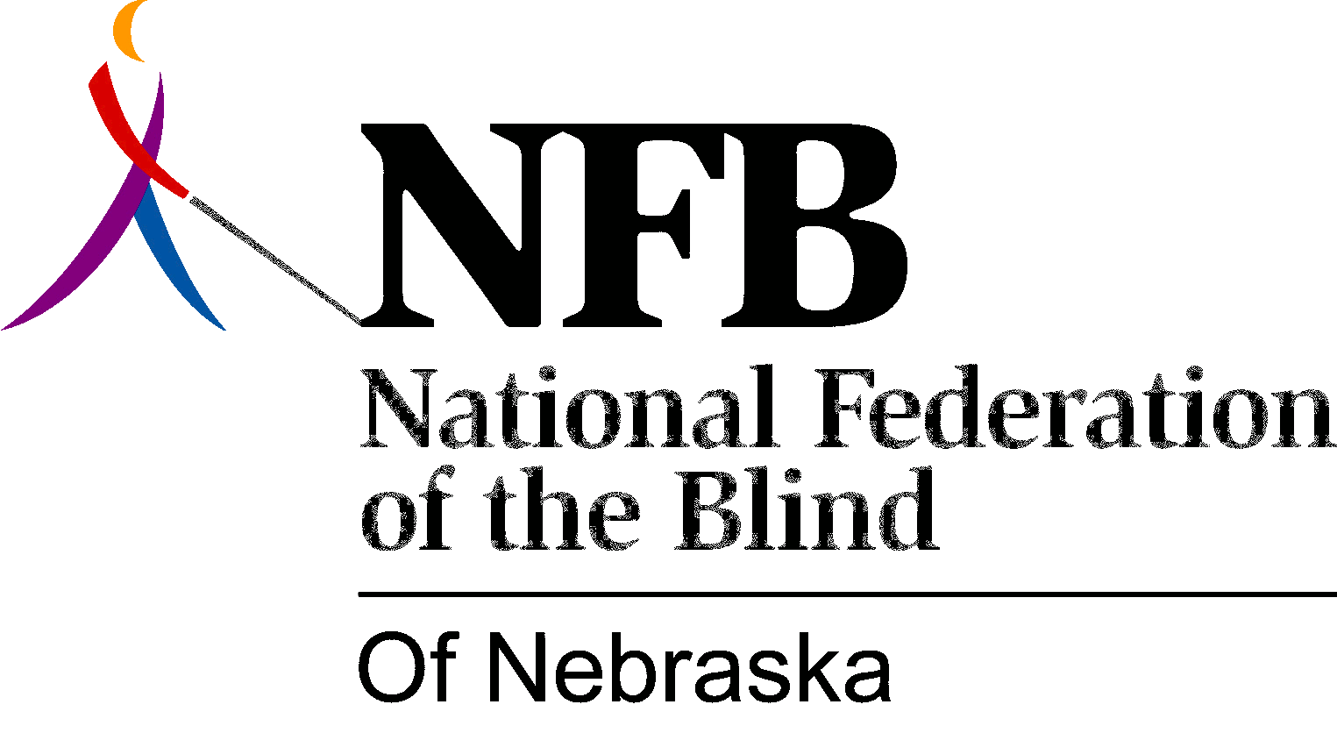

Resolution 1990-01

RE: American Charter Savings and Loan

WHEREAS, the American Charter Savings and Loan Association has shown consistent support and understanding of the Ideals and goals of the National Federation of the Blind; and

WHEREAS, American Charter has demonstrated its understanding by hiring and promoting the blind; and

WHEREAS, American Charter has worked with the blind to stimulate public awareness about the abilities of blind persons and to advocate further for the employment of the blind; and

WHEREAS, in June of 1990, when an urgent need for a corporate partner was brought to the attention of American Charter, American Charter immediately and generously rose to the occasion, solving the seemingly insoluble problem; now, therefore,

BE IT RESOLVED, by the National Federation of the Blind of Nebraska in convention assembled this 27th day of October, 1990, in the City of Kearney, Nebraska, that this organization express its heartfelt appreciation to American Charter for its long-standing support of the aspirations and actions of Nebraska's blind; and

BE IT FURTHER RESOLVED, that this organization hold up American Charter to Nebraskans as a model of good corporate citizenship.

Adopted unanimously.

