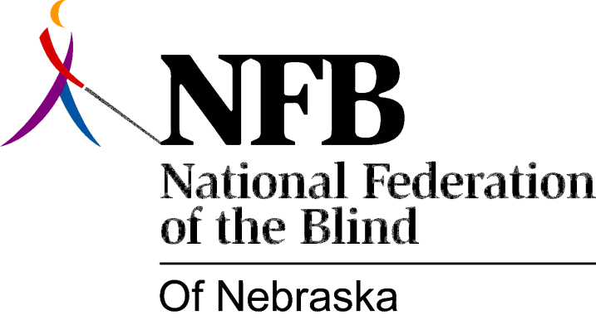

RESOLUTION 1984-06

RE: Affordable in State Bus Transportation

WHEREAS, the physical and economic access to public transportation is of primary importance to the independence of blind persons; and,

WHEREAS, many blind persons in Nebraska utilize bus transportation as their main source of transit between communities throughout the state; and,

WHEREAS, the Continental Trailways bus company has proposed a rate hike of seventy percent throughout Nebraska; and,

WHEREAS, the national Federation of the Blind is working to insure security, equality and opportunity for all blind people, and to combat such inequities as a seventy percent rate of unemployment or under-employment among the blind populations; and,

WHEREAS, the N.F.B. does not favor the establishment of a reduced rate or an exemption for blind persons; now, therefore,

BE IT RESOLVED, by the National Federation of the Blind of Nebraska, in convention assembled this 14th day of October, 1984, in the city of North Platte, Nebraska, that this organization take all steps necessary in opposition of this fare increase, including testimony before the Public Service Commission; and,

BE IT FURTHER RESOLVED, that the Secretary of this organization be instructed to send copies of this resolution to the officials of the Continental Trailways bus company and to any other appropriate individuals.

