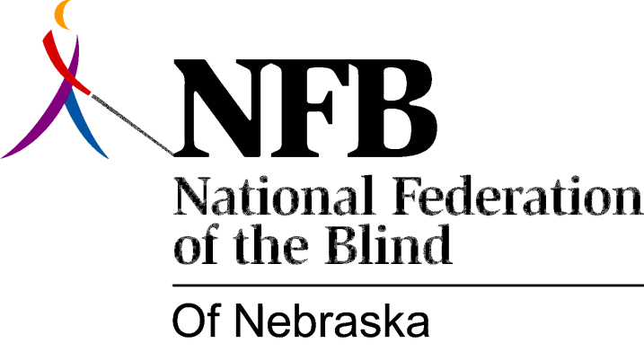

RESOLUTION 1984-04

RE: Walk-A-Thon Proceeds

WHEREAS, since 1980, the National Federation of the Blind of Nebraska has sent one hundred percent of its Walk-a-thon proceeds to our national treasury; and,

WHEREAS, in the fall of 1982, and again in the spring of 1984, it became necessary for this affiliate to request grants from our national treasury; and,

WHEREAS, on both of these occasions, the amount of money granted was in excess of our Walk-a-thon proceeds; and,

WHEREAS, in order to carry out membership recruitment, public education and all of the other work of the Federation, including additional fund-raising, operating capital is a necessity; now, therefore,

BE IT RESOLVED, by the National Federation of the Blind of Nebraska, in convention assembled this 14th day of October, 1984, in the city of North Platte, Nebraska, that following each annual Walk-a-thon, the Board of Directors of this organization shall assess the status of the treasury and submit a reasonable percentage of the proceeds to our national treasury, based on that assessment; and,

BE IT FURTHER RESOLVED, whenever possible, the National Federation of the Blind of Nebraska shall resume the practice of giving all Walk-a-thon proceeds to our national treasury.

