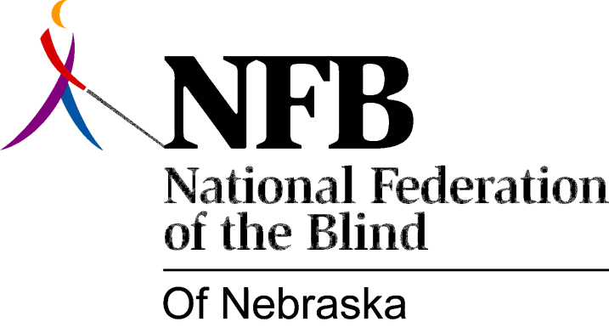

Resolution 1983 – 02
RE: National Federation of the Blind Month / White Cane Safety Day

WHEREAS, October has been proclaimed “National Federation of the blind Month” in Nebraska by Governor Kerrey; and,

WHEREAS, this proclamation also recognizes October 15 as National White Cane Safety Day; and,

WHEREAS, the Governor has appointed a representative to formally present the proclamation to our organization at our Convention Banquet: now, therefore,

BE IT RESOLVED, by the National Federation of the Blind of Nebraska in convention assembled this 16th day of October, 1983, in the city of Lincoln, Nebraska, that we commend the Governor for giving recognition to the National Federation of the Blind, the largest organization of the blind in Nebraska.

