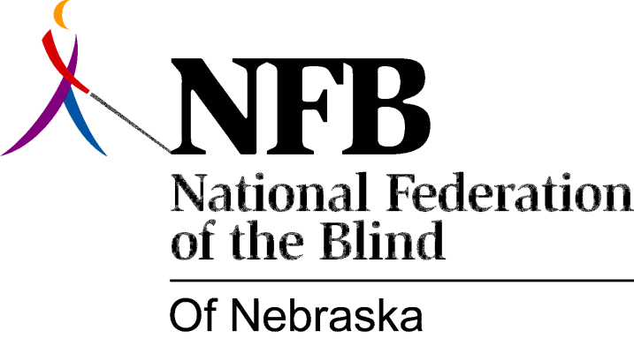

Resolution 1982 – 03
RE: Mrs. Corinne Adams, Educator of Blind Children

WHEREAS, we the members of the National Federation of the Blind of Nebraska, recognize the importance of quality education for all persons; and,

WHEREAS, this kind of education is often denied to blind people as a result of the negative attitudes and low expectations harbored by those who teach in schools for the blind; and,

WHEREAS, teachers who believe in their students as individuals capable of leading full and meaningful lives, and of competing on an equal footing with the sighted, are unfortunately, the exception rather than the rule; and,

WHEREAS, many of the more recent alumni of the Nebraska School for the Visually handicapped have expressed their respect and admiration for one such exceptional educator – namely, Mrs. Corinne Adams; and,

WHEREAS, members of the National Federation of the Blind of Nebraska who were taught by Mrs. Adams have attested to the fact that her encouragement played a major role in the development, on their part, of a positive self-image; and,

WHEREAS, this marks the final year of Mrs. Adams’ long and distinguished career at the Nebraska School for the Visually Handicapped; now, therefore,

BE IT RESOLVED, by the National Federation of the Blind of Nebraska, in Convention assembled, this 16th day of October, 1982, in the city of Grand Island, Nebraska, that this organization commend Corinne Adams and recognize her outstanding efforts and positive influence in the education of blind students; and,

BE IT FURTHER RESOLVED, that the Secretary of this organization send copies of this Resolution to Mr. Gerald Regler, Superintendent, Nebraska School for the Visually Handicapped, and to the Nebraska Board of Education, in order that proper appreciation and recognition be accorded.

