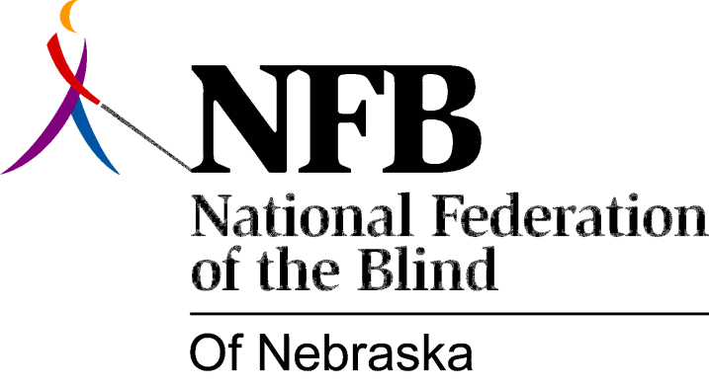

Resolution 1979 – 05
RE: Changes in the Nebraska Fair Employment Practices Act

WHEREAS, chapter 48-119, paragraph 3 of the Nebraska Fair Employment Practices Act, by the use of the word "intentionally" or references to intentional discrimination, limit and weaken the intent of the law and the powers of the Nebraska Equal Employment Opportunity Commission and,

WHEREAS, discrimination does exist without willful intent and is the product of unfounded assumption, myth and, misconception about the abilities of the blind and,

WHEREAS, subjective judgments of the blind, rather that bona fide occupational qualifications are used in screening out blind applicants and,

WHEREAS, the Nebraska Fair Employment Practices Act does not allow for Reasonable Accommodations and,

WHEREAS, the absence of "reasonable accommodations" provisions within the law conflicts with Sections 503 and 504 of Affirmative Action Guidelines of the Rehabilitation Act of 1973, Public Law 93-112, and,

WHEREAS, the blind are not generally sought after as a source of expertise and authority on issues directly concerning themselves now, therefore,

BE IT RESOLVED, by the National Federation of the Blind of Nebraska, in convention assembled this 19th day of May, 1979, in the city of Hastings, Nebraska, that this organization supports the elimination of any reference to "intentional discrimination" within the Nebraska Fair Employment Practices Act and,

BE IT FURTHER RESOLVED, that this organization also supports revision of this law to include "reasonable accommodation" so as to be in conformity with Federal Affirmative Action laws and,

BE IT FURTHER RESOLVED, that the President, the Board of Directors, and the Legislative committee take whatever action necessary to implement this resolution.

Passed Unanimously

