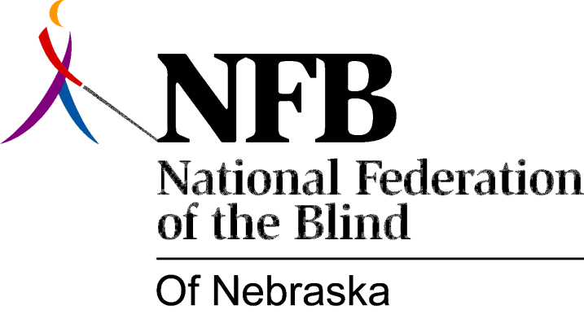

Resolution 1979 – 02
RE: Request for Planning Money for Remodeling and Construction of Division of Rehabilitation Services for the Visually Impaired.

WHEREAS, the Nebraska Unicameral, 86th Legislature, first session failed to appropriate funds for badly needed remodeling of, and construction at, the Division of Rehabilitation Services for the Visually Impaired’s building at 1047 South Street in Lincoln and,

WHEREAS, the Department of Public Institutions did not place the request for the planning money for this remodeling and construction on a high enough priority to be incorporated in its Construction request and,

WHEREAS, the Governor's Advisory Committee to the Division of Rehabilitation Services for the Visually Impaired, has recognized, is aware of and, in full support of the badly needed remodeling and construction and,

WHEREAS, the Division of Rehabilitation Services for the Visually Impaired has prepared a list of conservative recommendations for the remodeling and construction in its May 1, 1978, facility program statement and,

WHEREAS, the blind recognizes significant improvement in services provided to blind Nebraskans since May of 1974 now, therefore,

BE IT RESOLVED, by the National Federation of the Blind of Nebraska in convention assembled this 19th day of May, 1979 in the city of Hastings, Nebraska, that Governor Charles Thone, the Department of Public Institutions, and the Nebraska Unicameral, 86th Legislature, second session, be called upon to recognize the importance of supporting a Construction request for this remodeling and construction and,

BE IT FURTHER RESOLVED, that the Governor's Office and the Department of Public Institutions be urged to indicate their support of one of the better programs for the blind in this country by supporting this badly needed remodeling and construction and,

BE IT FURTHER RESOLVED, that copies of this resolution be sent to Governor Charles Thone, Jack M. Cleavenger, Director of the Department of Public Institutions and all members of the Unicameral.

Passed Unanimously

