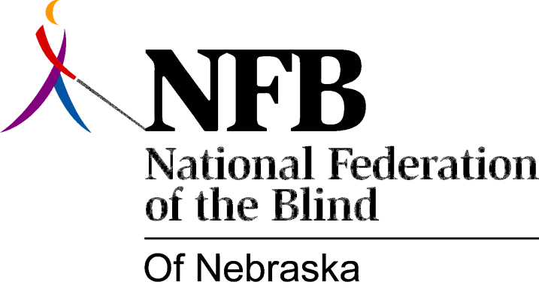

Resolution 1979 – 01
RE: Commendation on Insurance Rule 35

WHEREAS, the blind of the State of Nebraska have, in the past, been subject to the unfair and discriminatory practices and policies of insurance carriers regarding life and health insurance and,

WHEREAS, optional coverage in life and hospital insurance was denied to the blind totally on the basis of blindness and not actuarial and sound evidence to justify such discrimination and denial and,

WHEREAS, the actions of M. Berri Balka as Commissioner of Nebraska Department of Insurance with the able assistance of Michael Wapp, brought about antidiscrimination regulations through the promulgation of Rule 35, effective October 4, 1978, and,

WHEREAS, Commissioner Balka and Michael Wapp worked cooperatively with the National Federation of the Blind of Nebraska in establishing Rule 35 and equality in insurance for the blind, now, therefore,

BE IT RESOLVED, by the National Federation of the Blind of Nebraska, in convention assembled this 20th day of May, 1979, in the city of Hastings, Nebraska, that M. Berri Balka and Michael Wapp of the Nebraska Department of Insurance, be commended for their positive and responsible actions in assisting the blind in securing equality in insurance in the state of Nebraska and,

BE IT FURTHER RESOLVED that copies of this resolution be sent to M. Berri Balka, Michael Wapp and Governor Charles Thone.
Passed Unanimously

