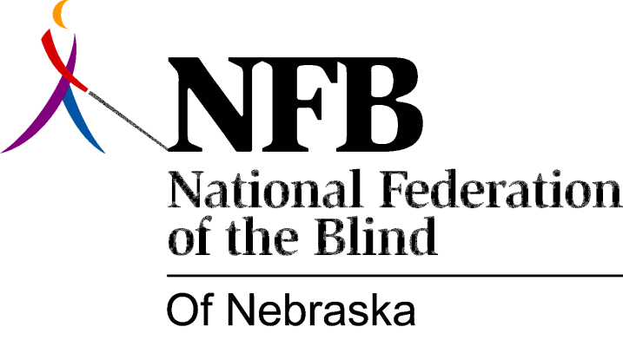

Resolution 1978 – 02
Re: Renaming of the NSVH/Parents' Committee

WHEREAS, the Nebraska School for the Visually Handicapped/Parents' Committee has had more activity than it can deal with effectively as one body and

WHEREAS, the size of the group has proved unwieldy and

WHEREAS, all of this committee's activities center around the education of the blind and the committee has found that their [word omitted]

WHEREAS, all of this committee's activities center around the education of the blind and the committee has found that their activities can be classified into two fundamentally related concerns--those concerns related to the Nebraska School for the Visually Handicapped, and those concerning parents of blind or visually handicapped children, now, therefore,

BE IT RESOLVED, by the National Federation of the Blind of Nebraska in convention assembled this 17th day of June, 1978, in the city of Omaha, Nebraska, that the current Nebraska School for the Visually Handicapped/Parents' Committee hereafter be called the Education Committee of the National Federation of the Blind of Nebraska whose subcommittees shall consist of the Nebraska School for the Visually Handicapped (NSVH) Liaison Committee and the Parents' Committee.

Passed unanimously, June, 1978.

