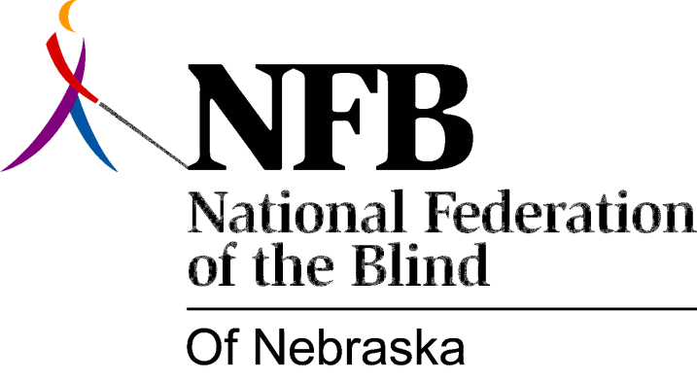

RESOLUTION 1977-11
RE: Nebraska Services for the Visually Impaired Assisting in the Education of School Administrators.

WHEREAS, Blind Persons Have Proven that they can teach Successfully in All Areas of Education; AND,
WHEREAS, Despite this record of achievement, Discrimination in Hiring still Exists; AND

WHEREAS, This discrimination is caused by lack of knowledge about blindness rather than ill will; AND,

WHEREAS, Services for the Visually Impaired is in a position to play an important role in educating school administrators about the abilities of blind teachers; NOW, THEREFORE,

BE IT RESOLVED by the national Federation of the Blind of Nebraska in Convention assembled this 15th day of May, 1977, in the city of Lincoln, Nebraska that Services for the Visually Impaired should assist in the education of administrators by conducting seminars for school administrators to acquaint them with the abilities of blind teachers.

Passed unanimously May 15, 1977

