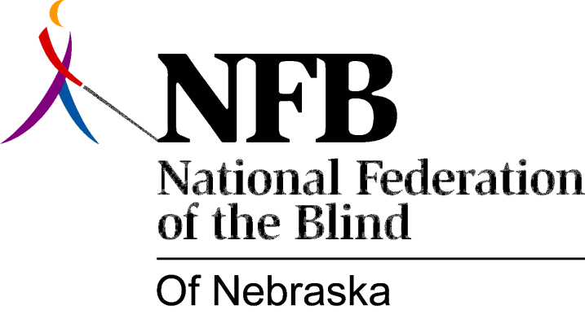

RESOLUTION 1977-06
RE: Expression of Concern Regarding the Loss of Consumer Representation on the Governor's Advisory Committee to the Nebraska Rehabilitation Services for the Visually Impaired.

WHEREAS, the 93rd Legislature of the State of Nebraska passed, and the Governor signed Legislative Bill 88 an ACT to create an Advisory Committee to the Department of Institutions to Aid in Providing Services for the Visually Impaired; AND

WHEREAS, Legislative Bill 99 Requires that the Governor, in making appointments to the Committee, shall seek to give fair representation to Organizations of the Blind and Visually Impaired Persons; AND,

WHEREAS, The two most recent positions available for reappointment were vacated by blind persons, each a representative of an organization of blind persons; AND

WHEREAS, The organizations involved made specific, formal, recommendations for appointment to the governor; AND

WHERAS, In neither case did the governor appoint a representative of either organization, but appointed sighted persons whose organizational affiliations were not pertinent to the work being carried on by Nebraska Rehabilitation Services for the Visually Impaired; AND,

WHEREAS, The National Federation of the Blind of Nebraska believes that it is essential that consumer organizations have representation in the affairs which affect their lives; NOW, THERFORE,

BE IT RESOLVED by the National Federation of the Blind of Nebraska in convention assembled this 14th day of May, 1977, in the city of Lincoln, Nebraska that this organization express its deep concern at this loss of Consumer Representation; AND,

BE IT FURTHER RESOLVED that this ORGANIZATION hereby petitions Governor J. James Exon to pledge in writing that the next vacancy created by a member who is not a consumer representative be filled by a representative recommended by the Omaha association of the Blind, or the Business Enterprise vendors of Nebraska; and that all future vacancies be filled within the prescription of the law, Especially that clause requiring that the Governor "... give fair representation to organizations of Blind and visually Impaired Persons."

Passed Unanimously May 14, 1977

