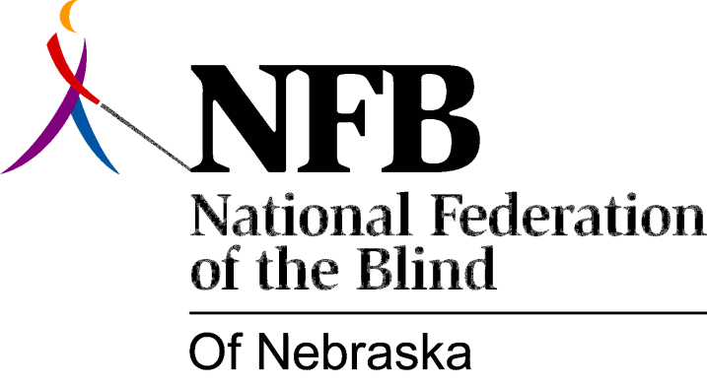

Resolution 1977-03
Re: Creation of a Standing Membership Committee

WHEREAS, Every member of the National Federation of the Blind of Nebraska is responsible for seeking out new members and explaining the goals and philosophy of the National Federation of the Blind to prospective new members, the public, and current members who may not fully understand; AND

Whereas, Although the foregoing is true, some organization has to be given to the effort of recruiting new members and expanding the organization; NOW, THEREFORE,

BE IT RESOLVED, By the National Federation of the Blind of Nebraska in Convention Assembled this 15th Day of May, 1977, in the city of Lincoln, Nebraska that the president of this organization shall appoint a standing membership committee whose purposes will be:

1. To Coordinate efforts in seeking out prospective members in areas where chapters do not exist,

2. To conduct seminars throughout the state to be open to members and those interested in joining, for the purpose of discussing the philosophy of the National Federation of the Blind and issues affecting the Blind.

3. To setup new chapters in areas where the need exists; AND

BE IT FURTHER RESOLVED, That the chairman of this committee shall present progress reports at every meeting of the board of directors of the National Federation of the Blind of Nebraska.

Passed Unanimously May 15, 1977

