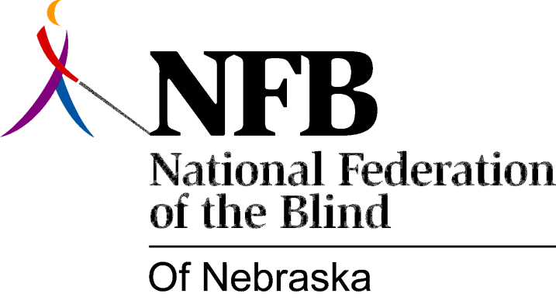

Resolution 1976 – 11
Re: Rights of Blind Voters

WHEREAS, the right to vote is the constitutional right of all citizens, and,

WHEREAS, there is a requirement that a blind voter be assisted in marking his ballot by a registered voter in the state of Nebraska, and,

WHEREAS, this requirement often denies the right of free choice on the part of the blind voter in the selection of the person assisting, thereby infringing on the constitutional intent that voting be a secret act, now, therefore,

BE IT RESOLVED, by the National Federation of the Blind of Nebraska, in convention assembled this 16th day of May, 1976, in the city of Grand Island, Nebraska, that the legislation committee of this organization be instructed to propose legislation in the 1977 Unicameral to eliminate the requirement in section 32-460 of the Nebraska State Statutes that “the person rendering assistance must be a registered voter in the State of Nebraska.”

This Resolution Passed Unanimously.

