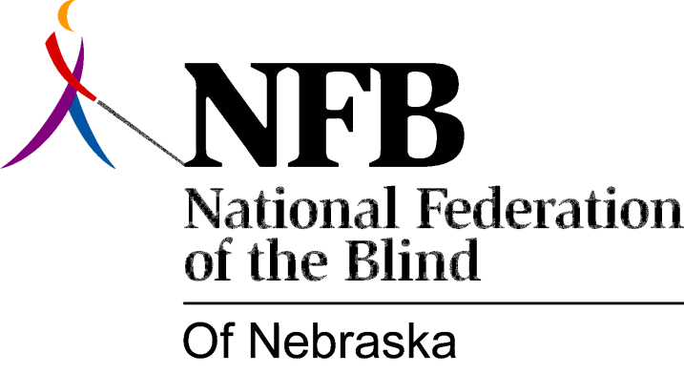

Resolution 1976 – 10
Re: Positive Attitude about Blindness

WHEREAS, the attitudinal development of a child is influenced by those surrounding him - his peers, his school and, his parents, and,

WHEREAS the National Federation of the Blind stresses the importance of blind people having a positive attitude toward themselves and blindness, now, therefore,

BE IT RESOLVED, by the National Federation of the Blind of Nebraska, in convention assembled this 15th day of May, 1976, in the city of Grand Island, Nebraska, that a committee be established to work with the Nebraska School for the Visually Handicapped and the parents of blind children to help make them more aware of this positive attitude.

This Resolution Passed Unanimously.

