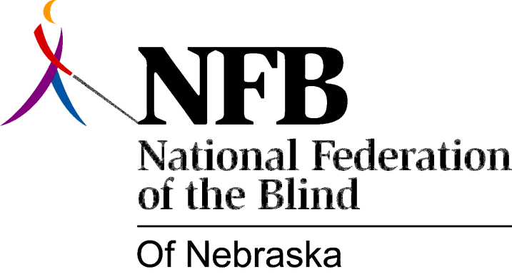

Resolution 1976 – 06
Re: Education of Government Officials about Blindness

WHEREAS, the goals of security, equality and, opportunity for the blind cannot be achieved without adequate and progressive legislation, and,

WHEREAS, members of the National Federation of the Blind of Nebraska, because of their firsthand knowledge and collective self-expression, are in a unique position to assist public officials in formulating policies which will advance these goals, now, therefore,

BE IT RESOLVED, by the National Federation of the Blind of Nebraska, in convention assembled this 15th day of May, 1976, in the city of Grand Island, Nebraska, that every member increase attempts to educate officials on all levels of government to the needs and abilities of blind persons.

This Resolution Passed Unanimously.

