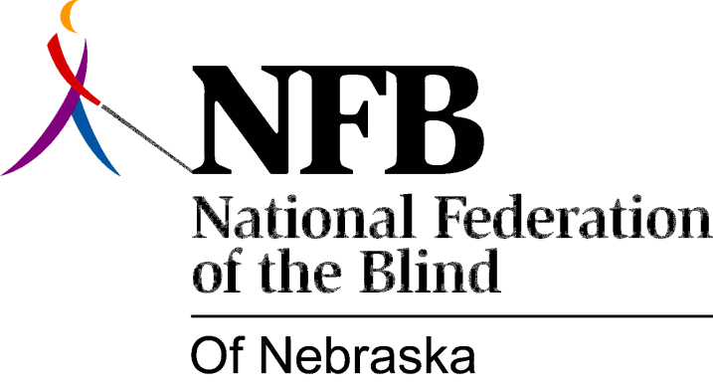

Resolution 1976 – 05
Re: Quality of Services Provided by the Nebraska Library Commission

WHEREAS, access to written material is vitally important to all persons, and,

WHEREAS, the Library for the Blind and Physically Handicapped is the major source of such material for blind Nebraskans, and,

WHEREAS, the blind have raised serious questions about the adequacy of such services for meeting consumer needs, and have therefore worked for a transfer of the administration of the library from the Nebraska Library Commission to the Division of Rehabilitation Services for the Visually Impaired, and,

WHEREAS, the legislature has adopted a resolution to study the Nebraska Library Commission as a whole, now, therefore,

BE IT RESOLVED, by the National Federation of the Blind of Nebraska, in convention assembled this 15th day of May, 1976, in the city of Grand Island, Nebraska, that this organization urges the Government, Military and, Veteran’s Affairs Committee to thoroughly investigate the present state of library services to the blind and physically handicapped through public hearings, comparisons with other library services for the blind and physically handicapped and an other actions which will guarantee quality library services to Nebraska’s blind and physically handicapped citizens, and,

BE IT FURTHER RESOLVED, that this organization go on record as continuing support of an administrative transfer as the first step in improving library services, and,

BE IT FURTHER RESOLVED, that the secretary be instructed to send copies of this resolution to Governor James j. Exon, and all members of the Government, Military and, Veteran’s Affairs Committee as well as any other government officials or members of the public who may help resolve this situation in a positive manner.

This Resolution Passed Unanimously.

