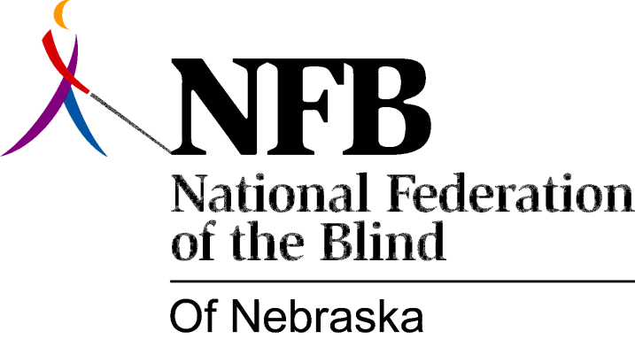

Resolution 1976 – 02
Re: Administration of the Library for the Blind and Physically Handicapped

WHEREAS, from all indications it is apparent that the Department of Public Institutions, Division of the Rehabilitation Services for the Visually Impaired had been willing to take a stand on L.B. 661 in the past session of the Unicameral, that stand, we feel sure, would have supported the stand of consumer groups of the blind , and,

WHEREAS, the Department of Public Institutions for whatever reason, chose neither to support or oppose L.B. 661, and apparently directed the Division of Rehabilitation Services for the Visually Impaired to take a similar middle-of-the-road position, now, therefore,

BE IT RESOLVED, by the National Federation of the Blind of Nebraska, in convention assembled this 15th day of May, 1976, in the city of Grand Island, Nebraska, that we urge the director of the Department of Public Institutions, Jack M. Clevenger, and further urge the Director of the Division of Rehabilitation Services for the Visually Impaired, James S. Nyman, to step forward and fully support such legislation as may be introduced in the 1977 Unicameral that would bring about the changes necessary to assign the administration of the Library for the Blind and Physically Handicapped to the Department of Public Institutions, Division of Rehabilitation Services for the Visually Impaired, and,

BE IT FURTHER RESOLVED, that governor James J. Exon, Senator Dennis Rasmussen, or any member of the government, Military and, Veteran’s Affairs committee be urged to request from the Director of the Division of Rehabilitation Services for the Visually Impaired a written proposal outlining the benefits to be achieved through this administrative transfer, and,

BE IT FURTHER RESOLVED, that the Secretary be instructed to send a copy of this resolution to Governor J. James Exon, Senator Dennis Rasmussen, all members of the Government, Military and, Veterans Affairs Committee, Jack M. Clevenger, and James S. Nyman.

This Resolution Passes Unanimously.

