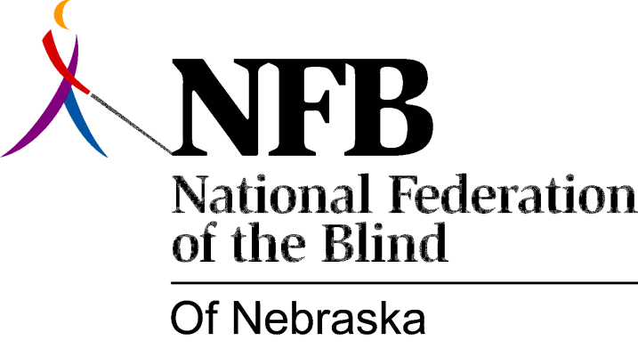

Resolution 1974 – 06
Re: Protest of the National Accreditation Council for Agencies Serving the Blind and Visually Handicapped

WHEREAS, the National Accreditation Council for Agencies Serving the Blind and Visually Handicapped (here after referred to as NAC) currently holds it’s self out as the dually authorized agency for organizations serving the blind; and,

WHEREAS, NAC has continuously refused to allow the organized blind representation on it’s board of directors and,

WHEREAS, NAC will be holding it’s board meeting in Cincinnati Ohio May 31st and,

WHEREAS, the National Federation of the Blind will be gathering in Cincinnati at a concurrent time to protest the above mentioned lack of responsiveness, now, therefore,

BE IT RESOLVED, by the National Federation of the Blind of Nebraska in convention assembled this 18th day of May 1974 that the NFB of Nebraska send a representative to Cincinnati for the express purpose of taking part in the National Federation of the Blind activities and,

BE IT FURTHER RESOVLED, that financial resources be extended to the chosen individual through a special collection of NFB of Nebraska members and friends to the blind to be completed no later than May 25, 1974

