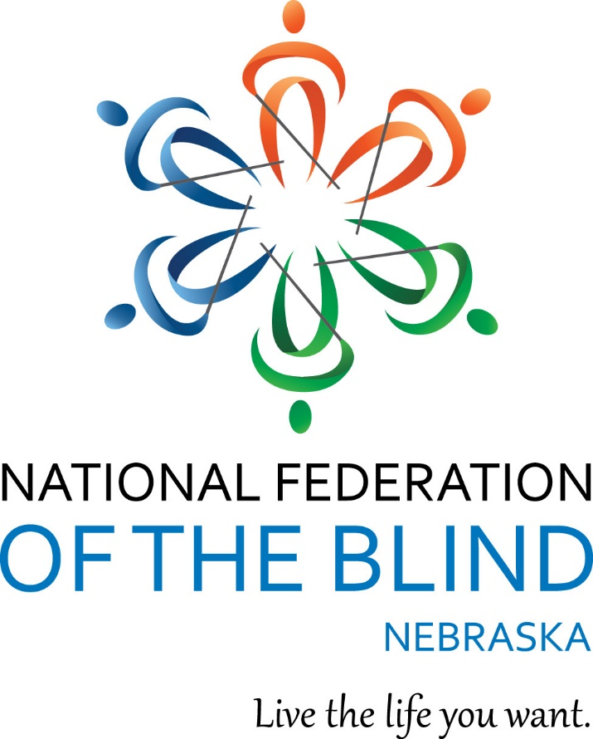

NATIONAL FEDERATION OF THE BLIND OF NEBRASKA  
Forward Together: Shaping Tomorrow  
54th Annual State Convention  
March 27 – 30, 2025  
Omaha Regency Marriott Hotel  
10220 Regency Circle  
Omaha, NE 68114

# Welcome from the Officers and Board of Directors

**Officers:**   
President, Jamie K. Richey, Lincoln, NE  
First Vice President, Christine Boone, Lincoln, NE  
Second Vice President, Bob Burns, Omaha, NE  
Secretary, Linda Mentink, Columbus, NE  
Treasurer, Cheryl Livingston, Lincoln, NE  
  
**Members of the Board of Directors:**Nancy Coffman, Lincoln, NE  
Geralyn K. Konruff, Chappell, NE  
Karen Lemmon, Whitney, NE  
Maura Loberg, Omaha, NE  
Rachna HK Marsh, Omaha, NE  
Kimberly Scherbarth, Kearney, NE   
  
**Connect with the National Federation of the Blind of Nebraska!**Like on Facebook: @nebraskasblind  
Follow on X: @nfbn  
Subscribe on YouTube: @NFBNE  
Visit Online: http://www.ne.nfb.org

## **BELIEF MESSAGE**

The National Federation of the Blind advances the lives of its members and all blind people in the United States. We know that blindness is not the characteristic that defines you or your future. Every day we raise the expectations of blind people, because low expectations create obstacles between blind people and our dreams. Our collective power, determination, and diversity achieve the aspirations of all blind people.  
  
 **CORE VALUES**• Believe in blind people  
• Lead courageously  
• Champion collective action  
• Foster inclusion  
• Dream big

# PLEDGE

I pledge to participate actively in the efforts of the National Federation of the Blind to achieve equality, opportunity and security for the blind; to support the policies and programs of the Federation; and to abide by its constitution.

# We wish to extend sincere gratitude to this year’s convention sponsors!

# Silver Level Sponsors

## The Johnson Family Matt and Donna Johnson, in honor of their daughter, Leah Johnson

# Bronze Level Sponsors



## **Independence Science**

Empowering A New Vision

Independence Science is a STEM consulting and access technology company specializing in the development of text-to-speech enabled scientific data collection interfaces. These products empower print-disabled students to have hands-on quantifiable learning experiences individually or as part of laboratory teams in science laboratory learning environments. Independence Science actively seeks research and development collaborations with entities interested in opening the doors of opportunities for the blind in science, math, engineering, and technology.

(866) 862-9665

[info@independencescience.com](mailto:info@independencescience.com)

[www.independencescience.com](http://www.independencescience.com)

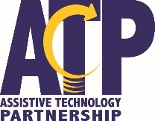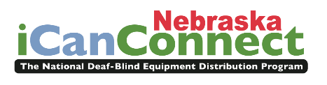Nebraska ICanConnect Program   
(Assistive Technology Partnership)Technology with a Purpose  
The Nebraska ICanConnect Program helps individuals with combined vision and hearing loss stay connected through specialized communication equipment. For over 10 years, the Assistive Technology Partnership has administered this national program in Nebraska, ensuring those with limited incomes can access phone, email and internet services.

Brooke.harrie@nebraska.gov  
(402) 679-4271  
[www.icanconnect.org](http://www.icanconnect.org)

 **NanoPac, Inc.**  
Assistive Technology for Independence  
**NanoPac, Inc. has been serving the blind and low vision community in Nebraska for nearly 40 years. Since 1987, we have represented leading manufacturers of blindness technology, providing products that empower individuals to live independently. Every low vision, braille, and blindness technology product we sell comes with lifetime support.**(402) 699-4357  
patrick@nanopac.com  
[www.nanopac.com](http://www.nanopac.com)

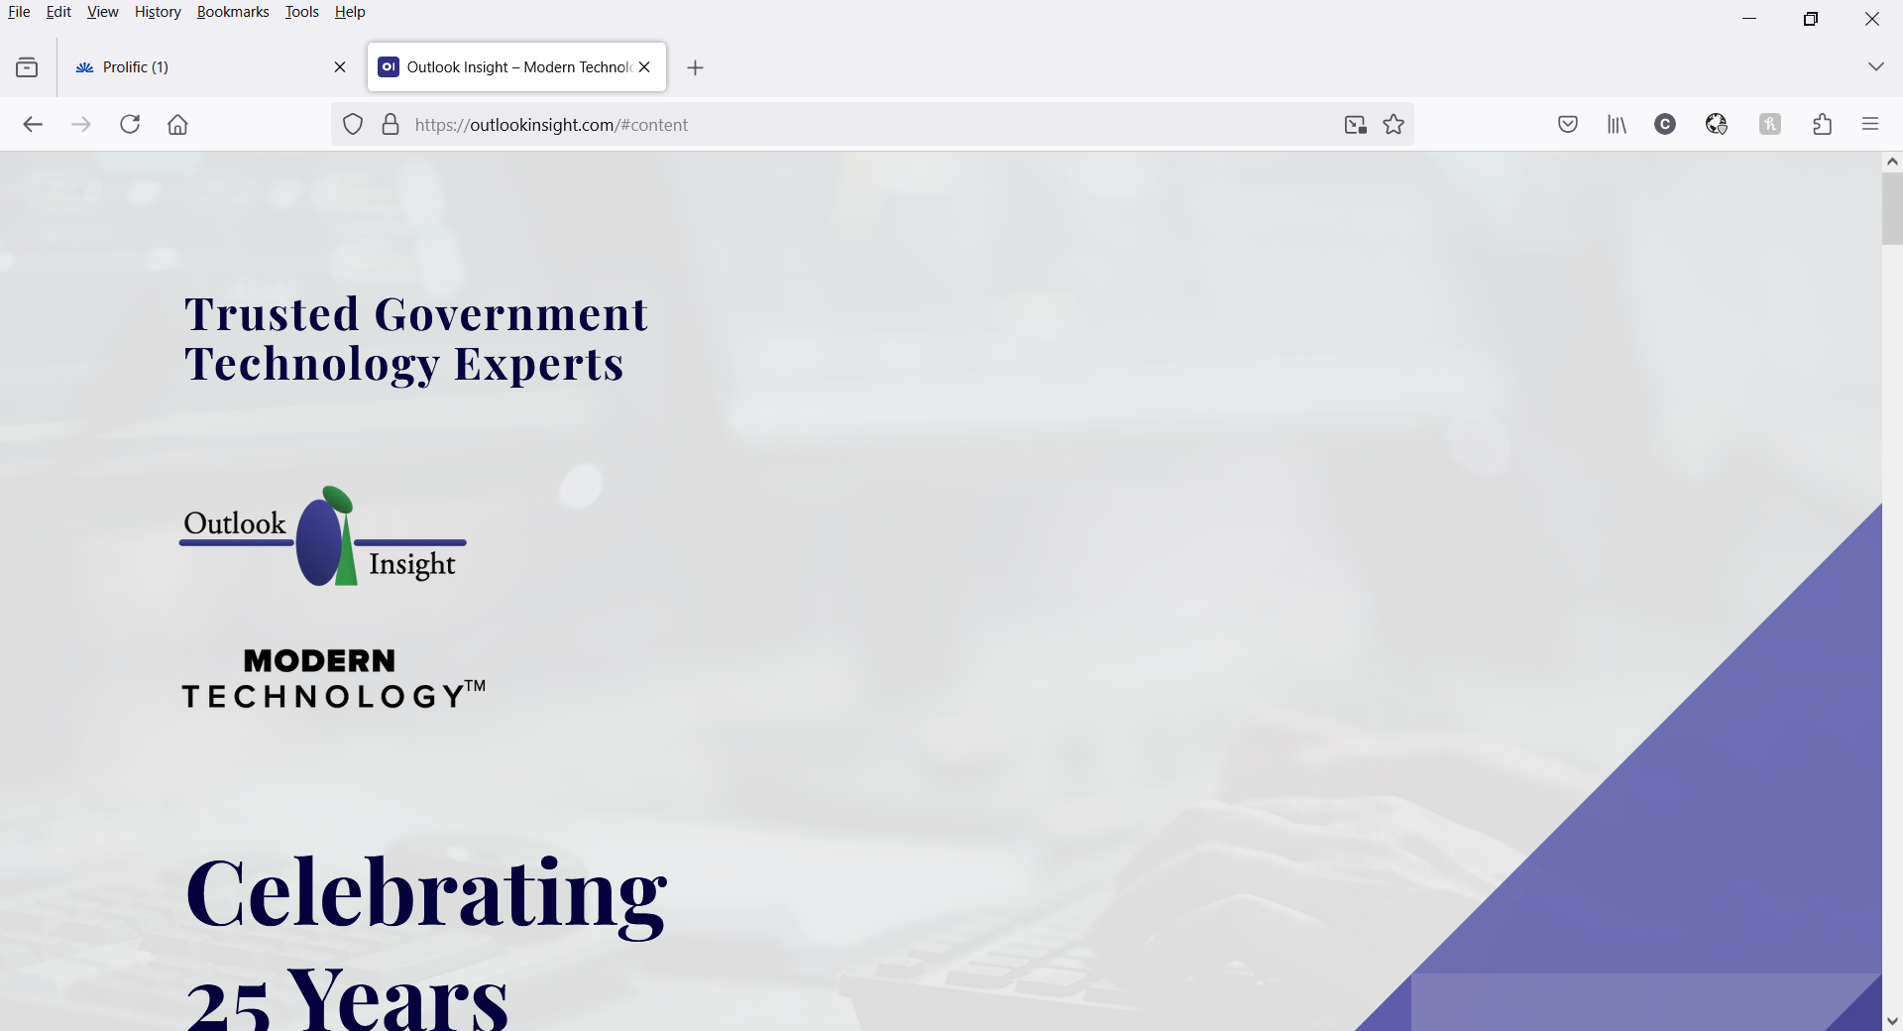  
**Outlook Insight, LLC**Outlook Insight LLC helps leaders build high-performing teams and advance accessibility through modern technology. We integrate AI-driven solutions with expert coaching to enhance efficiency, foster self-sufficiency, and drive innovation through inclusivity.  
(360) 288-8000  
admin@outlookinsight.com  
[www.outlookinsight.com](http://www.outlookinsight.com)

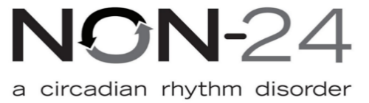

## **Vanda Pharmaceuticals, Inc.**

Innovate in the Service of People’s Pursuit of Happiness  
Non-24-Hour Sleep-Wake Disorder (Non-24) is a chronic condition that disrupts the body's natural sleep cycle. It affects up to 70% of people who are totally blind, many of whom may not even be aware they have it. Symptoms include difficulty falling asleep, staying asleep, excessive daytime sleepiness, and waking up feeling groggy or unrested.  
(202) 875-4714  
jennifer.lyman@vandapharma.com  
[www.vandapharma.com](http://www.vandapharma.com)

In-Kind Sponsors



## **WayAround®**

See beyond the limits of a visual world.  
Founded by two architects with vision loss, WayAround® is more than just an app—it’s a game-changer in accessible information. With a simple tag-and-scan system, it provides instant details about everyday items. At this year’s convention, a WayTag on your badge will give you quick access to the agenda, exhibitor packet, and other key information. Simply scan it using the free WayAround app for iOS or Android and experience a smarter way to navigate the event!  
(888) 898-4465  
connect@WayAround.com  
[www.WayAround.com](http://www.WayAround.com)

The National Federation of the Blind of Nebraska Welcomes Our Honored Guests!  
  
**National Representative: Gary Wunder, National Federation of the Blind**Gary has been a dedicated member of the National Federation of the Blind since the age of 16, holding numerous leadership positions throughout his decades of service. At the chapter level, he served as Corresponding Secretary, Recording Secretary, Treasurer, and President. At the affiliate level, he served as a board member, First Vice President, and Affiliate President from 1979 to 2017, with a brief two-year interruption. On the national level, Gary served on the National Board of Directors starting in 1985, serving as both a board member and Corporate Secretary. His first assignment as a national representative came in 1987. In addition, he contributed extensively to the Scholarship Committee until stepping aside to create opportunities for new leaders.  
  
Professionally, Gary’s career has been varied and impactful. He has worked as a factory worker in a sheltered workshop, a retail salesperson in an electronics store, and a computer programmer for the University of Missouri and briefly for Cerner Corporation. From June 2010 to December 2024, Gary served as the editor of the Braille Monitor. Currently, he is employed full-time with the Federation, where he is focused on transitioning the Monitor, collecting oral interviews, and assisting in the digitization of the Jacobus tenBroek Library. As with many roles in the Federation, his responsibilities also include “other duties as assigned.”

Outside of his professional life, Gary treasures time with his family. He has four children, four grandchildren, and a wonderful wife named Debbie who is a leader in her own right. He enjoys reading, engaging in meaningful conversations, and staying active through exercise. A self-described politics enthusiast, Gary is deeply interested in current events.   
  
Gary is passionate about the Federation’s work and believes in the importance of cultivating the next generation of leaders. While he loves tradition, he is open to change and values the fresh perspectives younger people bring to the table.

**Joshua Olukanni, Second Vice President, National Association of Blind Students**Joshua is honored to serve as Second Vice President of the National Association of Blind Students. His journey with the National Federation of the Blind began with the guidance of strong, independent mentors from the Georgia affiliate, who showed him the boundless potential of blind individuals. Inspired by their example, he attended BLIND, Inc., where he gained valuable skills and personal growth.  
  
Following his training, Joshua pursued higher education at the University of Minnesota, where he is currently an upper-class student majoring in Human Resource Development with minors in Psychology and Management. Outside of academics, he enjoys weightlifting, watching anime, and creating content as he works toward a career in the entertainment industry.  
  
**Paul Sandoval, Vice President, National Association of Guide Dog Users**Paul resides in Lakewood, Colorado, with his wife Shawn and their two children, Mia and Paul Jr. He is the proprietor of Blind Tech Training, an assistive technology company dedicated to empowering blind and low vision customers throughout Colorado and neighboring states.  
  
Since 2014, Paul has been an active member of the National Federation of the Blind. He serves as Vice President of the National Association of Guide Dog Users and serves on the NFB of Colorado Board of Directors , the Colorado Blind Parents division board, and is president of the Wild West chapter in Lakewood, Colorado. His first guide dog, Yonkers, a Yellow Lab from Guide Dogs for the Blind, has recently retired, marking a significant chapter in his journey.  
  
In his leisure time, Paul enjoys spending quality time with his family and friends, supporting his local sports teams, and attending Reggae concerts.  
  
**J.J. Meddaugh, Founder and CEO, A.T. Guys**A.T. Guys is a technology sales, training, and consulting company based in Kalamazoo, Michigan. Since 2008, A. T. Guys has developed and distributed products that empower people who are blind or visually impaired while collaborating with a range of businesses, including Fortune 500 companies, on accessibility and usability initiatives. In his free time, J.J. participates actively in the Michigan affiliate and enjoys playing goalball, playing the keyboard, and exploring local cuisines.

**Dr. Merry-Noel Chamberlain, Teacher of Students with Visual Impairments, Orientation & Mobility Instructor, Education Service Unit #3**  
Dr. Merry-Noel Chamberlain, hailing from Omaha, is a distinguished educator and advocate in the field of blindness. Serving as a Teacher of Students with Visual Impairments and an Orientation and Mobility Instructor for Educational Service Unit #3, she brings over three decades of dedicated experience to her profession.  
  
Blind for the past 26 years, Dr. Chamberlain's personal journey enriches her professional insights. She and her husband are proud parents of two daughters. Their eldest, Royene, has expanded their family with four grandchildren and a great-grandchild. Their youngest, Ashleah, who is blind, was adopted from China at the age of eight and is set to graduate from the University of Nebraska Omaha in May.  
  
Beyond her roles in education, Dr. Chamberlain is an active contributor to Future Reflections, a publication of the National Federation of the Blind. Her commitment to the community is further exemplified through her authorship of two insightful books: The ABCs of Structured Discovery Cane Travel for Children and Structured Discovery Cane Travel Approach to Orientation and Mobility Concepts. These works, available on Amazon, offer practical activities for parents and educators to impart essential orientation and mobility concepts to children.  
  
Through her multifaceted roles as an educator, author, and advocate, Dr. Merry-Noel Chamberlain continues to make a profound impact on the lives of individuals who are blind and low vision and their families.

CONVENTION DETAILS

**Registration**

All convention attendees must register. Registration grants access to the convention room rate and eligibility for door prizes. If you are pre-registered, please visit the registration area to pick up your packet. If you have not yet registered, you may do so onsite for a $30.00 fee. **Please note: Meal tickets will NOT be available for purchase onsite.** Registration times will be strictly followed to ensure our members can fully participate in convention activities. Refer to the agenda for registration times and locations.

## **Information Table**

Located just outside the general session room, the Information Table is your go-to spot for assistance. Federationists will be available to answer questions and provide guidance throughout the convention. This table will also serve as the lost and found, so be sure to check here for any misplaced items.

**Assistive Listening Devices**

An FM transmitter system is available for those who need assistance. Visit the information table for details.

**Guide Dog Relief Area**

The dog relief area is located in the West Courtyard of the hotel, next to the fitness center. To get there, from the front doors of the hotel, the reception area will be on your left. Walk straight ahead down the hallway until you reach an area to turn left. This will take you to the Walnut Grand Ballroom Foyer, the. You’ll notice an exit door at this turn, but **do not exit through these doors**. Instead, continue walking through the foyer, all the way down the hall, until you reach the exit next to the fitness center. Turn right out the door and the relief area will be on your right.

Please be courteous and pick up any waste and dispose of it in the trash can provided.

**Door Prizes**

A variety of door prizes will be drawn during each general session and at the banquet. Attendees must be registered with the convention to be eligible for a door prize and must be present to win. Drop off all door prize donations in the registration area during the assigned registration times.

# AGENDA

# Thursday, March 27, 2025

6:00 - 8:00 p.m. Registration and Packet Pick-Up  
Millard Boardroom  
Cheryl Livingston, Coordinator, Registration Arrangements

7:00 - 10:00 p.m. Welcome Reception  
Regency Ballroom  
Light Hors D’oeuvres and a cash bar will be available.  
Christine Boone, Chair, Convention Arrangements Committee

## **Friday, March 28, 2025**

7:30 - 9:00 a.m. Registration and Packet Pick-Up  
Millard Boardroom  
Cheryl Livingston, Coordinator, Registration Arrangements  
  
7:30 - 8:30 a.m. Greater At-Large Chapter Meeting  
Dundee  
This is the annual face-to-face meeting of the chapter. Chapter members are encouraged to attend, and guests are welcome!  
Kimberly Scherbarth, President, National Federation of the Blind of Nebraska Greater At-Large Chapter

## **General Session I**

Salons A, B, C and D

9:00 a.m. Call to Order  
Jamie K. Richey, President, National Federation of the Blind of Nebraska, Lincoln, NE  
  
9:05 a.m. Invocation  
Shane Buresh, Member, National Federation of the Blind of Nebraska, Lincoln, NE  
  
9:10 a.m. Convention Logistics  
Christine Boone, Chair, Convention Arrangements Committee, Lincoln, NE  
  
9:20 a.m. Welcome to a Greater Omaha  
Becky Phipps, Director of Business Development, Greater Omaha Chamber, Omaha, NE  
  
9:40 a.m. National Report  
Gary Wunder, National Representative, National Federation of the Blind, Columbia, MO   
  
10:25 a.m. Fit Break  
  
10:30 a.m. Talking Books: New Products and Innovations for 2025  
Gabe Kramer, Executive Director, Nebraska Library Commission Talking Book and Braille Service, Lincoln, NE

10:50 a.m. Radio Talking Books: The Next 50 Years of Access  
Bekah Jerde, Executive Director, Radio Talking Book Service, Omaha, NE   
  
11:10 a.m. Shaping Tomorrow: The Path to Success for Nebraska’s Blind Youth  
Dr. Tanya Armstrong, Superintendent, Nebraska Center for the Education of Children who are Blind or Visually Impaired, Lincoln, NE  
  
11:30 a.m. Final Announcements  
  
11:45 a.m. Adjourn

12:00 - 1:00 p.m. Luncheon and Keynote Address: **Exploring Without Limits: Advancing Museum Accessibility**Regency Ballroom  
John Olson, CEO, 3DPhotoWorks, Bekah Jerde, Executive Director, Radio Talking Book Service, and Gary Wunder, National Federation of the Blind

1:00 p.m. - 6:00 p.m. Exhibits  
Grand Foyer and Salon E  
Refer to the exhibitor packet for a list of exhibitors and descriptions.  
Note: Prove you have visited all the exhibitors by getting your exhibitor card punched at each table and win some cash! The cards will be collected, and a drawing will take place on Sunday morning. Must be present to win.

1:00 - 2:00 p.m. Registration and Packet Pick-Up  
Millard Boardroom  
Cheryl Livingston, Coordinator, Registration Arrangements

1:15 - 5:00 p.m. Forward Together: Unlocking the Future  
Dundee  
Sponsored by the Nebraska Association of Blind Students, this 30-minute escape room challenge invites you to work together to solve clues and unlock the future. Explore NFB philosophy and the tools shaping tomorrow while having fun! The cost is $5 per person, and it's best enjoyed in groups of four. Don’t miss this engaging opportunity to collaborate and learn! Text (402) 925-8538!

1:15 - 5:00 p.m. Be Tactile  
Salon D  
Join our exclusive Be Tactile Breakout Session to explore the full Be Tactile Program and experience the Tactile Impressions Studio Quarterly Kit firsthand. Create one of our elegant, textured cards during the session, using luxury materials and guided techniques. Plus, enjoy the exclusive opportunity to pre-order and take home the complete kit, which is available in limited quantities. Don’t miss this chance to craft, discover and elevate your gifting with effortless sophistication! Two sessions will be held, and space is limited to 25 participants per session.  
Jeni Charlston, CEO, Kreative Keepsake

1:15 - 3:00 p.m. High Tech, Low Tech, Show & Tech  
Blackstone  
Dive into the world of technology, from high-tech gadgets to low-tech solutions. This session will highlight a variety of tools and innovations to help you navigate the future. Bring your favorite piece of tech or app to share with the group and discover new ways to enhance your daily life!  
J.J. Meddaugh, CEO, A. T. Guys   
  
3:15 - 5:00 p.m. AI in Action: Transforming Daily Life at Work and Home  
Blackstone  
Artificial Intelligence is no longer a futuristic concept — it’s here, shaping how we work, live and navigate the world. In this session, we’ll explore practical ways to integrate AI into your daily life, from enhancing workplace productivity to simplifying household tasks. Whether you're using AI for accessibility, efficiency, or creativity, this discussion will provide real-world applications and insights to help you harness the power of AI in both professional and personal settings. Join us to discover how AI can be a significant change in shaping a more independent and empowered future. Brought to you by AI-Works in partnership with the Nebraska Commission for the Blind and Visually Impaired.

7:00 p.m. NFB of Nebraska Board of Directors Meeting  
Salons A, B, and C  
Join the quarterly board meeting of the affiliate to learn about the latest updates, discuss key topics, and hear from board members on important initiatives. Everyone is welcome to attend.

7:30 p.m. Resolutions Committee  
Salons A, B, and C   
All attendees are encouraged to attend, as this is where you will learn about the resolutions for this year. Resolutions which pass the committee will then be voted on by the membership during general sessions of the convention. Resolutions are the birthplace of what becomes the policy and action of our affiliate.  
Barbara Loos, Chair, Resolutions Committee

8:00 - 10:00 p.m. Forward Together: Unlocking the Future  
Dundee  
Sponsored by the Nebraska Association of Blind Students, this 30-minute escape room challenge invites you to work together to solve clues and unlock the future. Explore NFB philosophy and the tools shaping tomorrow while having fun! The cost is $5 per person, and it's best enjoyed in groups of four. Don’t miss this engaging opportunity to collaborate and learn! Text (402) 925-8538!

8:00 - 10:00 p.m. Trivia  
Regency Ballroom  
Gather your team or join one on the spot for a fun and fast-paced trivia challenge! From NFB history to general knowledge and surprise questions, this exciting event will keep you on your toes. Come ready to compete, learn and share some laughs—who will take home the trivia chocolate?  
$5 per person per round; a cash bar will be available.  
Jeff and Deb Altman, Facilitators

## **Saturday, March 29, 2025**

7:30 - 8:00 a.m. Nominating Committee  
Dundee  
This is the only closed meeting within the National Federation of the Blind of Nebraska and consists of a delegate from each chapter and division.  
Christine Boone, Chair, Nominating Committee  
  
8:00 - 9:00 a.m. Registration and Packet Pick-Up  
Millard Boardroom  
Cheryl Livingston, Coordinator, Registration Arrangements  
  
8:00 - 11:30 a.m. Exhibits  
Grand Foyer and Salon E  
Refer to the exhibitor packet for a list of exhibitors and descriptions.  
Note: Prove you have visited all the exhibitors by getting your exhibitor card punched at each table and win some cash! The cards will be collected, and a drawing will take place Sunday morning. Must be present to win.   
  
8:00 - 9:45 a.m. Senior Division Annual Business Meeting  
Salon D  
Join us for the Senior Division’s Annual Business Meeting, where we’ll discuss important updates, upcoming initiatives and opportunities for involvement. This is your chance to connect with fellow seniors in the blind and low vision community, share your experiences and contribute to shaping the future of the division. Be part of the conversation as we work together to strengthen our community and continue advocating for the needs of blind seniors.  
Robert Newman, President, National Federation of the Blind of Nebraska Senior Division

8:00 - 9:45 a.m. Nebraska Association of Blind Students Annual Business Meeting  
Blackstone  
Whether you're a high school student preparing for college, an adult learner exploring a new path, a seasoned college attendee, or an educator working with blind and low vision students, this meeting is for you! Learn about the division and discover how you can get involved!  
Lucas Griess, President, Nebraska Association of Blind Students  
  
10:00 – 11:45 a.m. **Shaping Healthier Tomorrows: Diabetes Management**Salon D  
Join us for an informative seminar on managing diabetes with the latest technology and expert tips. Learn about innovative tools to help with blood sugar monitoring, insulin management and overall health. Discover the dos and don'ts of living with diabetes and find out how you can get involved in the community to share experiences and gain support. Whether you're newly diagnosed or experienced, this session will provide valuable insights.  
Gary Wunder, Facilitator   
  
10:00 - 11:45 a.m. Shaping Tomorrow with Puppy Paws: The Guide Dog Experience  
Blackstone  
Curious about guide dogs? Ever wondered what it’s like to have one? This session covers the benefits of guide dog mobility, school programs, application processes, and real-life experiences. Hear from guide dog users, learn about different training programs and get updates from the National Association of Guide Dog Users.  
Paul Sandavol, Vice President, National Association of Guide Dog Users and Maura Loberg, Owner, Jojo the Guide Dog  
10:00 - 11:45 a.m. Parents Group Round Table  
Dundee  
Join us for an open and supportive discussion designed for parents of blind children and blind parents alike. This round table is a chance to ask questions, share experiences, give and receive advice, and connect with others who understand the journey. Children are welcome—be part of this empowering conversation!  
Lesa Griess, Facilitator

12:00 - 1:00 p.m. Luncheon and Keynote Address: Shaping Tomorrow Through Structured Discovery   
Regency Ballroom  
Dr. Merry-Noel Chamberlain, Teacher of Students with Visual Impairments, Orientation & Mobility Instructor, Education Service Unit #3

## **General Session II**

Salons A, B, C and D

1:30 p.m. Call to Order   
Christine Boone, First Vice President, National Federation of the Blind of Nebraska, Lincoln, NE  
  
1:35 p.m. Invocation  
Nancy Oltman, Member, National Federation of the Blind of Nebraska, Hastings, NE  
  
1:40 p.m. Presidential Report  
Jamie K. Richey, President, National Federation of the Blind of Nebraska, Lincoln, NE

2:00 p.m. Report from the National Association of Blind Students  
Joshua Olukanni, Second Vice President, National Association of Blind Students, Minneapolis, MN  
  
2:20 p.m. Future Leaders on the Hill: The Power of Student Advocacy  
Lucas Griess, President Nebraska Association of Blind Students, Atkinson, NE; Benjamin Grelk, Vice President, Nebraska Association of Blind Students, Lincoln, NE; and Hay Paw, Member, Nebraska Association of Blind Students, Madison, NE  
  
2:40 p.m. Fit Break  
  
2:45 p.m. Forward Together: Advancing Services for the Blind   
Carlos Servan, Executive Director, Nebraska Commission for the Blind and Visually Impaired, Lincoln, NE   
  
3:05 p.m. The Impact of SSPs in the DeafBlind Community  
Brett Wilhelm, DeafBlind Services Program Manager, Vancro Integrated Interpreting Services, O'Fallon, MO  
  
3:25 p.m. Maximizing Impact: Understanding the PAC Program  
Barbara Loos, Chair, Pre-Authorized Contribution Program Committee, Lincoln, NE  
  
3:45 p.m. Bells Will Be Ringing: Shaping the Future One Dot at a Time  
Lesa Griess, Coordinator, NFB Braille Enrichment for Literacy and Learning® Academy of Nebraska

3:55 p.m. From the UK to the USA: Moving Forward Together  
Sania Kellogg, Member, National Federation of the Blind of Nebraska, Lincoln, NE  
  
4:15 p.m. Reports and Resolutions  
  
4:30 p.m. Adjourn  
  
6:00 p.m. Portrait Studio   
Regency Ballroom Foyer  
Dress your best and say cheese! We will be taking current photos for archival purposes. Don’t miss the chance to have your picture taken before the banquet!  
Sandy Wright, Photographer

6:00 p.m. Cocktail Reception   
Regency Ballroom  
Kick off the evening with great company and a refreshing cocktail! Get a sneak peek at the exciting auction items, purchase a duck for the Lucky Ducky game, and enjoy a relaxed atmosphere with friends before the banquet begins.  
  
7:00 p.m. Annual NFB of Nebraska Banquet  
Barbara Loos, Master of Ceremonies, Lincoln, NE  
Invocation: Linda Mentink, Secretary, National Federation of the Blind of Nebraska, Columbus, NE  
  
Keynote Address: Gary Wunder, National Representative, National Federation of the Blind, Columbia, MO

NFB of Nebraska Scholarship Presentation: Bob Burns, Chair, Scholarship Committee, Omaha, NE  
  
Get on the PAC Program: Barbara Loos, Chair, Pre-Authorized Contribution Program Committee, Lincoln, NE

**Pre-Authorized Contribution (PAC) Program Form**

This program allows you to contribute to the National Federation of the Blind through recurring monthly donations. These donations can be made via direct withdrawals from your checking account or charges to your credit card. To start a new monthly donation or update your existing PAC plan, please scan the QR Code below.

For questions, please contact:  [PAC@nfb.org](mailto:PAC@nfb.org)

Thank you for your generosity and support.

PAC QR

9:00 - 11:00 p.m. The Pitch Pipes and Annual Auction  
Regency Ballroom  
Grab your friends and get ready for a night of music and excitement! The Pitch Pipes will entertain with lively cover tunes. Between songs, you’ll have the chance to bid on fantastic items in our annual auction. A cash bar will be available.  
Jeremy Fifield and Maura Loberg, Facilitators

## **Sunday, March 30, 2025**

7:30 - 8:30 a.m. Non-Denominational Devotions  
Salon D  
Start your day with reflection and inspiration at our Non-Denominational Devotions. This welcoming session offers a time for prayer, encouragement, and shared wisdom, open to all who wish to participate.  
Christine Boone and Linda Mentink, Facilitators

## **General Session III**

Salons A, B, and C

9:00 a.m. Call to Order  
Jamie K. Richey, President, National Federation of the Blind of Nebraska, Lincoln, NE  
  
9:05 a.m. Invocation  
Kimberly Scherbarth, Board Member, National Federation of the Blind of Nebraska, Kearney, NE  
  
9:10 a.m. Final Logistics  
Christine Boone, Chair, Convention Arrangements Committee, Lincoln, NE  
  
9:20 a.m. Shaping Tomorrow: How Will We Do It  
Shane Buresh, Member, National Federation of the Blind of Nebraska, Lincoln, NE

9:50 a.m. Minutes of the 2024 NFB of Nebraska Business Meeting  
Linda Mentink, Secretary, National Federation of the Blind of Nebraska, Columbus, NE  
  
10:00 a.m. 2024 Annual Treasurer's Report  
Cheryl Livingston, Treasurer, National Federation of the Blind of Nebraska, Lincoln, NE  
  
10:10 a.m. Roll Call of Chapters and Divisions  
A. Greater At-Large Chapter  
B. Lincoln Chapter  
C. Omaha Chapter  
D. Nebraska Association of Blind Students  
E. Senior Division  
F. Parents Group  
  
10:45 a.m. Fit Break

10:50 a.m. Resolutions Committee Report  
Barbara Loos, Chair, Resolutions Committee, Lincoln, NE  
  
11:00 a.m. PAC Program Report  
Barbara Loos, Chair, Pre-Authorized Contribution Program Committee, Lincoln, NE  
  
11:10 a.m. Scholarship Awards  
Bob Burns, Chair, Scholarship Committee, Omaha, NE  
  
11:20 a.m. Nominating Committee Report  
Christine Boone, Chair, Nominating Committee, Lincoln, NE  
  
11:30 a.m. Election of Board Members  
  
11:50 a.m. Final Remarks  
  
12:00 p.m. Adjourn