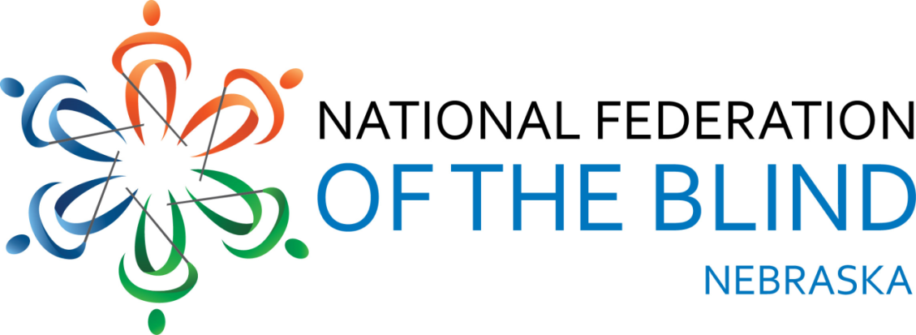

Resolution 2019 – 01

RE: Regarding Making neworks.nebraska.gov Accessible to Blind Users

WHEREAS, neworks.nebraska.gov is a government website provided by the Nebraska Department of Labor; and

WHEREAS, the Section 508 refresh mandates that government websites meet the accessibility standards set forth in WCAG 2.1 AA to be accessible to all users regardless of disability; and

WHEREAS, the Nebraska Access Technology Clause also requires technology and services to be accessible to Nebraskans regardless of disability; and

WHEREAS, although recent changes to the site have improved the accessibility of some operations, they have left many features, services and pages inaccessible, such as clickable objects that do not activate, tables that are improperly formatted and cannot be navigated as tables, and assessments that do not allow the user to select choices independently; and

WHEREAS, a variety of services exist to help developers create and maintain accessible web content: Now, therefore

BE IT RESOLVED by the National Federation of the Blind of Nebraska in Convention assembled this twelfth day of October, 2019, in the city of Columbus, Nebraska, that this organization call upon the Nebraska Department of Labor (NDOL) to demonstrate a full commitment to accessibility by working with us to acquire the assistance necessary to update their website to conform with WCAG 2.1 AA using an organization that is qualified and has a reputation for effective website accessibility remediation; and

BE IT FURTHER RESOLVED that this organization urge the NDOL, as part of its continuing site maintenance, to have an ongoing relationship with said entity and to refrain from releasing future updates until they meet the standards of WCAG 2.1 AA, thus ensuring that their site will remain accessible to the blind of Nebraska and beyond.

