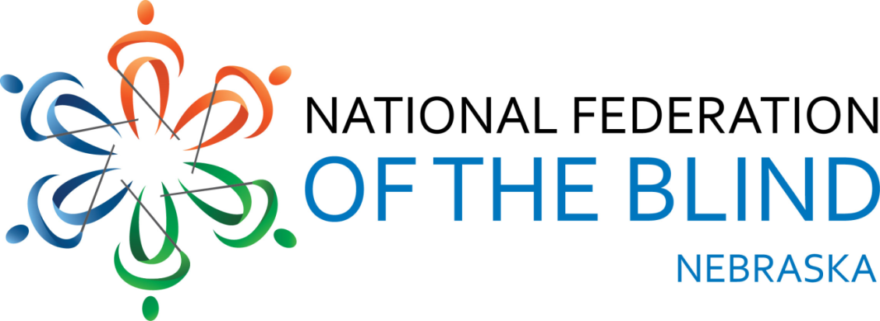

Resolution 2015 – 01

RE: Strengthening of Accessibility Policies and Practices in State Government

WHEREAS, the National Federation of the Blind of Nebraska, as part of its work to establish the Nebraska Commission for the Blind and Visually Impaired in the late 1990’s, assisted in the development of the Nebraska State Technology Access Standard; and

WHEREAS, every State-issued contract for information technology is to contain a Technology Access Clause that upholds this standard; and

WHEREAS, the State purchases a vast variety of electronic hardware and software; and

WHEREAS, the past two governors have emphasized the continued growth of electronic government and self-service electronic applications; and

WHEREAS, the State of Nebraska has purchased a number of systems whose vendors asserted that they were accessible, but use of these systems by blind Nebraskans either employed by State Government or who wanted to obtain jobs therein or consume services thereof proved the systems to be unusable and inaccessible using screen access technology; and

WHEREAS, the vendor’s assertions are taken at face-value with little to no supporting evidence or usability testing by the State or a designated, reputable testing entity and

WHEREAS, systems are already well-established by the time blind Nebraskans have the opportunity to use them, discover whether or not they are accessible, and either express concerns or suggest possible fixes; and

WHEREAS, this fact makes it highly unlikely that an inherently inaccessible system will be replaced with a more accessible one in a hasty fashion: Now, therefore,

BE IT RESOLVED by the National Federation of the Blind of Nebraska in Convention assembled this fir^{st} day of November, 2015, in the city of Norfolk, Nebraska, that this organization strongly urge the State of Nebraska and all related entities to hire or contract with a reputable authority who can test proposed systems for accessibility and adherence to the guidelines of the State Technology Access Standards; and

BE IT FURTHER RESOLVED that we work with Legislators and other government officials to examine and strengthen procurement statutes to include language making it mandatory to verify the accessibility claims of a vendor before its system ultimately is implemented.

