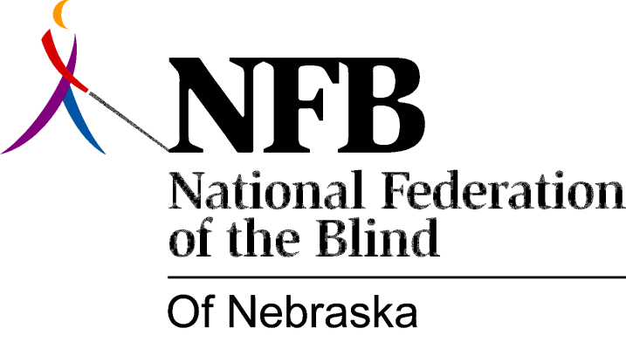

Resolution 2012 – 01
RE: Regarding Accessible Voting

WHEREAS, the Federal Government passed the Help America Vote Act in 2002; AND,

WHEREAS, the State of Nebraska began the implementation and use of accessible electronic voting machines in 2004; AND,

WHEREAS, on October 1, 2012 and following the accessible Automark voting machine in the Lancaster County Election Commission Office was not ready and available for use by blind and other qualified voters who required it for fair and equal early ballotting along with their sighted peers: Now, therefore,

BE IT RESOLVED by the National Federation of the Blind of Nebraska in Convention assembled this thirteenth day of October, 2012, in the City of Kearney, Nebraska, that we call upon all elections officials in the state of Nebraska and its 93 counties to insure the full implementation of the Help America Vote Act with accessible voting technology to be operational at all polling places available for early voting as well as on election day; AND,

BE IT FURTHER RESOLVED that this organization declare its firm intent to take all steps necessary (including pursuit of state legislation if needed) to secure the rights of blind persons to use of accessible voting technology in all elections held for public office at all levels within the state of Nebraska.

