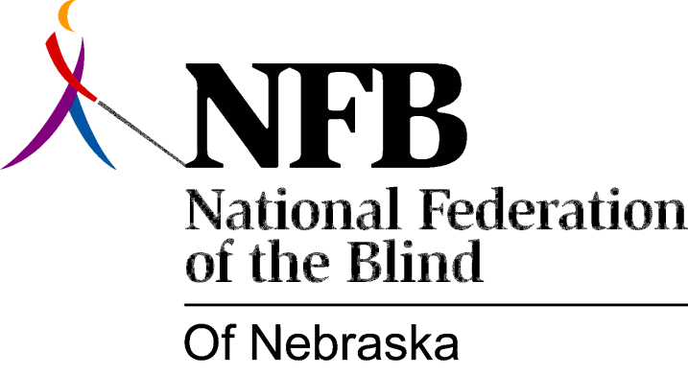

Resolution 2011 – 01
RE: Access To Educational Technology.

WHEREAS, public schools receive funding from the State of Nebraska; and

WHEREAS, colleges within the Nebraska State College System and universities are funded and regulated as part of State Government; and

WHEREAS, the Nebraska Technology Access Clause requires that all technology purchased by Nebraska state entities be accessible to people who are blind or have other disabilities; and

WHEREAS, many schools at all levels from elementary to postgraduate school have explored or are exploring the possibility of electronic textbooks, mobile access to electronic book information, online education and collaboration tools, and other emerging educational technologies; and

WHEREAS, the civil rights offices of the United States Department of Justice and the United States Department of Education issued a Dear Colleague letter dated June 29, 2010, reminding higher education institutions of their legal obligation to procure and deploy accessible educational technology; and

WHEREAS, in a Frequently-Asked-Questions document issued on May 26, 2011, the Department of Education emphasized that K-12 schools are also covered by federal nondiscrimination laws and thus required to procure and deploy accessible educational technology, and provided specific guidelines regarding the evaluation, procurement, and deployment of emerging educational technologies to ensure that they are accessible to the blind and other students with disabilities; and

WHEREAS, while a few e-reading applications and devices, such as Apple's iBooks application for its iPhone, iPod Touch, and iPad devices, take advantage of text-to-speech and Braille technology to deliver the content of commercially available e-books to the blind and others with print disabilities, and other providers of e-reading solutions are promising to provide access, many such devices and applications, such as the Sony Reader and Barnes and Noble Nook, are still inaccessible to the blind and print-disabled; and

WHEREAS, other electronic, online, and cloud-based tools being marketed to educational institutions, including the Google Apps for Education suite of cloud-based applications, are wholly or partially inaccessible to students who are blind or cannot read print; and

WHEREAS, blind students have found their education compromised by online learning systems and devices that do not meet Nebraska's standards for accessibility: Now, therefore,

BE IT RESOLVED by the National Federation of the Blind of Nebraska in Convention assembled this sixteenth day of October, 2011, in the city of Lincoln, Nebraska, that this organization condemn and deplore the use of inaccessible technologies by educational institutions supported by Nebraska tax dollars; and

BE IT FURTHER RESOLVED that this organization insist on the enforcement of the Technology Access Clause by the Nebraska State Department of Education, Nebraska Community College System, Nebraska State College System and the University of Nebraska System; and

BE IT FURTHER RESOLVED that, in the event an inaccessible system is implemented, this organization will support students in negotiation with both the specific school and the educational system.

