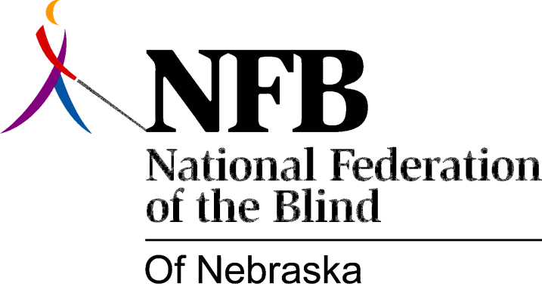

RESOLUTION 2002-01

RE: Nebraska Information System

WHEREAS, the National Federation of the Blind of Nebraska (NFBN) is an affiliate of the National Federation of the Blind NFB), our country’s oldest and largest organization of the blind; and

WHEREAS, the NFB promotes security, equality, and opportunity for the blind; and

WHEREAS, most blind individuals are both qualified and willing to work; and

WHEREAS, in spite of the efforts of the NFB, the unemployment rate among the blind remains at 75 percent; and

WHEREAS, one of the biggest barriers to employment is equal access to information; and

WHEREAS, in April of 2000, with the help of the NFBN, the Nebraska State Legislature passed LB352 which, in part, prohibits State Government in Nebraska from purchasing any technology that is not fully and equally accessible to the blind; and

WHEREAS, in August of 2001, the State entered into a contractual agreement with JD Edwards for the creation of the Nebraska Information System (NIS) JD Edwards One World; and

WHEREAS, in this contract, JD Edwards agreed to make the NIS system accessible to the blind; and

WHEREAS, the State of Nebraska has entered into a contract to pay $29,700,000 (twenty-nine million seven hundred thousand dollars) for this system; and

WHEREAS, the Nebraska Commission for the Blind and Visually Impaired has involved itself in the process of making sure that this system is truly accessible with the use of speech output software; and

WHEREAS, while the Commission’s Technology Program Director has repeatedly sought the opportunity to work directly with the JD Edwards developers, the company has not so far honored this request; and

WHEREAS, in two of the NIS newsletters, the accessibility issue was a focus and the point of what is meant by “fully accessible” was clearly explained, leaving no doubt that JD Edwards, at some level, should be aware of the issue; and

WHEREAS, the testing of and training with this system has begun, while accessibility for the blind has yet to be achieved; and

WHEREAS, it is inappropriate, unreasonable, impractical, and unacceptable for the State of Nebraska to expect that it can get the system up and running, online and implemented for everyone else, while taking a “wait and see” attitude about accessibility for the blind with no guarantee of either success or compliance with legal requirements; and

WHEREAS, it is far wiser to insist that the vendor, JD Edwards, deliver on its assurances of an accessible system before training and implementation of its various components becomes a reality than to try to correct the problem after the fact; now, therefore,

BE IT RESOLVED by the National Federation of the Blind of Nebraska, in Convention assembled this thirteenth day of October, 2002, in the city of Kearney, Nebraska, that this organization call upon the State of Nebraska, through the Office of the Governor, to enforce the terms of State Law, under Section 73-205 of the Nebraska Statutes; Federal Law, under both the Americans with Disabilities Act and Section 508 of the Rehabilitation Act of 1998; and the contractual agreement with JD Edwards regarding accessibility for the blind; and

BE IT FURTHER RESOLVED that this organization forward this resolution to the Governor of the State of Nebraska, the Nebraska Attorney General, and the Unicameral; and

BE IT FURTHER RESOLVED that this organization enter into any and all necessary actions, including negotiation or litigation, to ensure that the Nebraska Information System (NIS) JD Edwards One World is made fully accessible to the blind before anything further is done toward either offering training or bringing any part of the system online.

