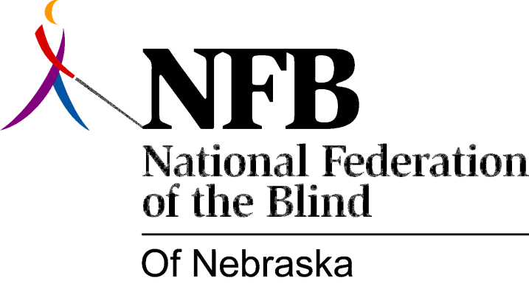

RESOLUTION 2001-02

RE: State Rehabilitation Council

WHEREAS, the Rehabilitation Act of 1973, as amended, required that each State rehabilitation agency, general and blind, establish a State Rehabilitation Advisory Council (SRAC), later called State Rehabilitation Council (SRC); AND

Whereas, each State Rehabilitation Council was required to have representation from several categories of programs, organizations and individuals; and

WHEREAS, the majority of the members were to be representatives of professional rather than consumer interests-for example, Client Assistance Program, Vocational Rehabilitation, community rehabilitation programs, business, industry and labor; and

WHEREAS, the Act contains an exception to the requirement of a Rehabilitation Council when an agency is operated by a consumer-controlled board; and

WHEREAS, THE Nebraska Commission for the Blind and Visually Impaired is such an agency; and

WHEREAS, at its meeting on August 4, 2001, the State Rehabilitation Council voted to seek changes in State Law that would permit the dissolution of the Council: Now, therefore,

BE IT RESOLVED by the National Federation of the Blind of Nebraska, in Convention assembled this seventh day of October, 2001, in the city of North Platte, Nebraska, that this organization promote and support any and all legislative efforts to dissolve the State Rehabilitation Council for the Nebraska Commission for the Blind and Visually Impaired.

