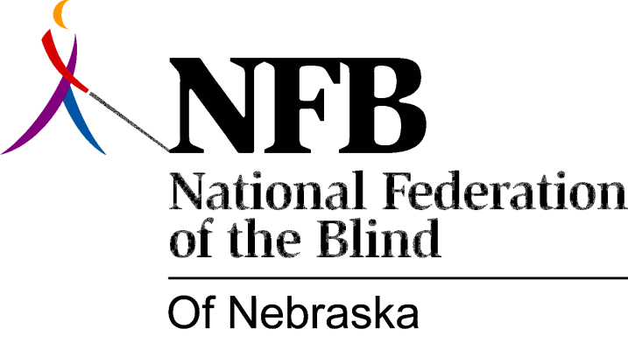

Resolution 2000-04
RE: Offices for Disabled Students
WHEREAS, the National Federation of the Blind of Nebraska has long fought for the right of blind people to receive equal education; and
WHEREAS, an integral part of equal education for the blind is to receive materials in accessible media in a timely manner; and
WHEREAS, it is widely taken for granted that the blind take longer to complete tasks, making it necessary to allow them more time to fulfill educational requirements; and
WHEREAS, as part of society, the blind themselves find it hard to resist buying into this misconception; and
WHEREAS, anyone, either blind or sighted, takes longer to accomplish any given task if materials are late or inaccessible; and
WHEREAS, this situation often results in a vicious circle of negative self-fulfilling prophecy; and
WHEREAS, the timely provision of print materials in the preferred accessible format is, according to the Americans with Disabilities Act (ADA), the responsibility of the educational system; and
WHEREAS, the Services for Students with Disabilities office on the University of Nebraska, Lincoln campus and other similar offices throughout the state have fallen short of meeting this requirement, making it difficult for blind students to succeed in their educational endeavors; now, therefore,
BE IT RESOLVED by the National Federation of the Blind of Nebraska in Convention assembled this eighth day of October, 2000, in the city of Omaha, Nebraska, that this organization call upon offices for disabled students throughout the state to work in partnership with us to bring together resources, equipment, and training opportunities which will enable blind students to receive print materials in accessible media in a timely manner.

