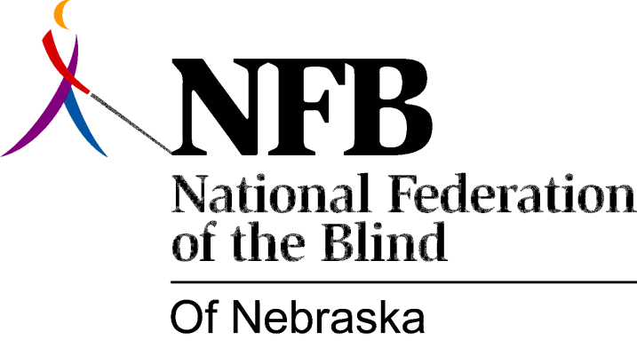

Resolution 1999-02

RE: DHHS Fair Employment of the Blind

WHEREAS, the National Federation of the Blind of Nebraska is the oldest and largest organization of the active blind in this state—the voice of the blind speaking for themselves; and

WHEREAS, one of our goals is to promote equality, opportunity and security for the blind in employment; and

WHEREAS, the Nebraska Department of Health and Human Services (DHHS) employs approximately five thousand eight hundred (5800) persons in a multitude of capacities including, but not limited to, rehabilitation of the blind, making it the largest employer in State Government; and

WHEREAS, outside of the agency specifically established to provide services for the blind, which has a few blind people among its total staff of forty-five (45), DHHS employs an estimated total of three (3) blind persons; and

WHEREAS, this disparity suggests either a pattern of discrimination or a lack of understanding about the capabilities of the blind on the part of DHHS; Now, therefore,

BE IT RESOLVED by the National Federation of the Blind of Nebraska, in Convention assembled this tenth day of October, 1999, in the city of Scottsbluff, Nebraska, that this organization urge the Nebraska Department of Health and Human Services (DHHS) to work cooperatively and affirmatively with us to achieve a full, fair and appropriate level of employment for the blind within the Department.

