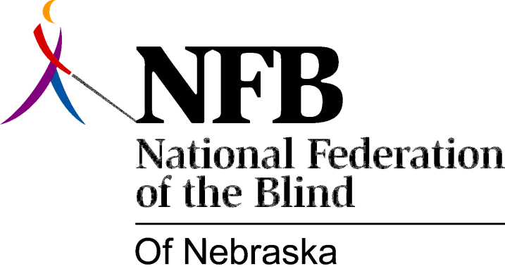

Resolution 1995-01

RE: Hosting Events for Nebraska School for the Visually Handicapped

Whereas, the National Federation of the Blind of Nebraska has a long history of reaching out to the Nebraska School for the Visually Handicapped; and

Whereas, the Federation's outreach efforts have included: career fairs, informational seminars and "fun night" events, which have been mutually beneficial to NSVH students and NFBN members; and

Whereas, in recent years, these activities have ceased; Now, therefore,

Be it resolved, by the National Federation of the Blind of Nebraska, in convention assembled this 21st day of October, 1995, in the city of Grand Island, Nebraska, that this organization sponsor an event for the students at the Nebraska School for the Visually Handicapped, to take place during the spring semester, 1996; and

Be it further resolved, that we call upon Bill Mann, Superintendent of the Nebraska School for the Visually Handicapped, to work cooperatively with the NFBN in supporting and scheduling this activity, and in encouraging all students and staff to attend.

