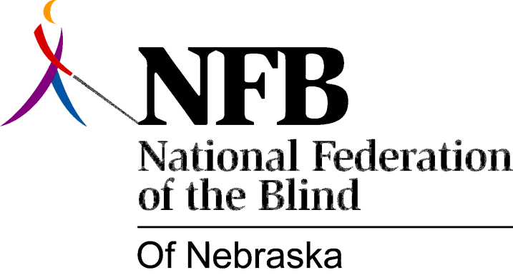

Resolution 1987 – 01
RE: Fostering Positive Attitudes About Blindness

Whereas, one of the goals of this organization is to foster positive attitudes about blindness among the general public; and,

Whereas, the majority of the public gets its information from the print and broadcast media (seventy-five percent of those persons rely on television); and,

Whereas, the media has had a history of not dealing with blindness in a reasonable or appropriate manner, often opting to sensationalize everyday activities done by blind persons; and,

Whereas, one exception to such misrepresentation has been the Community Affairs Department of KETV, Channel 7, Omaha, Nebraska; and,

Whereas, plans were implemented with Betty Denny, Community Affairs Manager of the above-named station, to produce and air a three-part series on blindness—misconceptions, parenting and employment; and,

Whereas, this organization submitted an outline of possible questions and answers to be used by the reporter, Mary Agnes (Aggie) Suazo, for the interview; and,

Whereas, this outline was followed almost exclusively by Mrs. Suazo; and,

Whereas, this series, aired twice daily on August 12, 13th and 14th during the 6:30 A.M. and the 11:30 A.M. news programs;

Whereas, much positive feedback has been received concerning the items dealt with in the series; now, therefore,

Be it resolved, by the National Federation of the Blind of Nebraska, in convention assembled this tenth day of October, 1987 in the city of Norfolk, Nebraska, that this organization commends Betty Denny, Mary Agnes Suazo, David Gonzales (photographer), and the management of KETV, Channel 7, for its excellent production of this series; and,

Be it further resolved, that this organization continue its close relationship with Channel 7, since it has expressed a willingness to continue to work with us in the production of local public service announcements; and,

Be it further resolved, that this organization submit copies of this resolution to the above-named persons, and to Barbara Pierce, Director of Community Affairs, National Federation of the Blind.

