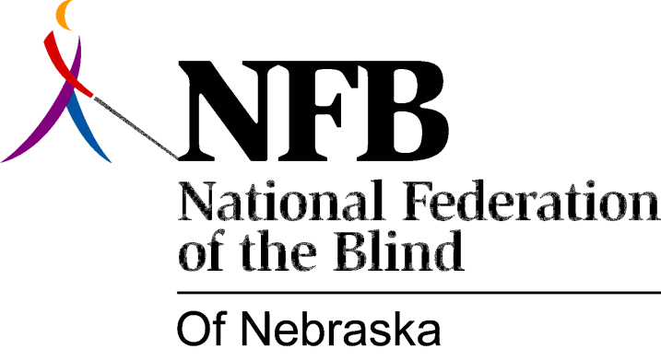

RESOLUTION 1985-01

RE: The Kennelly Amendment and Interstate Rest Area Vending

WHEREAS, seventy percent (70%) of working age blind people capable of working are unemployed or underemployed; and,

WHEREAS, the Randolph-Sheppard Act has and continues to employ thousands of blind Americans; and,

WHEREAS, the U.S. Congress has enacted the Kennelly Amendment allowing blind people to operate vending facilities in rest areas on interstate highways; and,

WHEREAS, Interstate 80 is a major national transportation route, carrying hundreds of thousands of vehicles annually across Nebraska, providing a very large potential clientele; and,

WHEREAS, the Kennelly Amendment provides for flexibility in implementation as it is administered: Now, Therefore,

BE IT RESOLVED by the National Federation of the Blind of Nebraska, in Convention assembled this 13th day of October, 1985, in the city of Grand Island, Nebraska, that the President of this organization direct the Legislative Committee to author and introduce into the Legislature a bill to implement the Kennelly Amendment.

