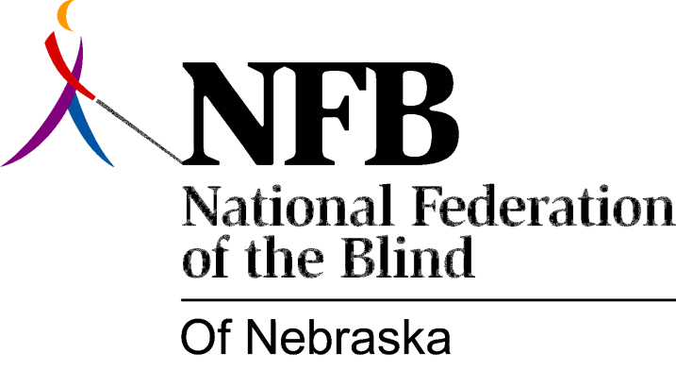

RESOLUTION 1984-102

RE: Rights and Responsibilities of Blind Bus Riders

WHEREAS, on May 24, 1984, representatives of the National Federation of the Blind of Lincoln, Nebraska, met with bus operators of the Lincoln Transportation System in order to discuss the rights and responsibilities of blind bus riders; and,

WHEREAS, at the time those representatives clearly stated that it is the right of each blind rider to choose whether or not he or she will accept or request assistance from any LTS operator; and,

WHEREAS, many attempts have been made previously in an effort to outline reasonable treatment of the blind; and,

WHEREAS, confusion continued to arise with respect to the treatment of blind riders; and,

WHEREAS, the statements made by representatives of this organization at the May 24th meeting have been badly misinterpreted: now, therefore,

BE IT RESOLVED by the National Federation of the Blind of Lincoln, Nebraska, in meeting assembled this 21st day of July, 1984, in the city of Lincoln, Nebraska, that in order to avoid any further misunderstandings, we set forth the following position:

- Operators should identify their bus routes to any blind rider waiting at a location serving more than one bus route.

- It is the responsibility of the blind rider to wait for buses in a visible place. If a rider is waiting in a place which is inconvenient or which is not a bus stop, an operator should notify the individual of this fact.

- It is the responsibility of the blind rider to request assistance in finding a seat if such help is desired. If unsolicited assistance is offered, the blind rider has the option to accept or decline.

- Operators may be asked to notify the blind rider when reaching a requested location. In such instances, it is reasonable for an operator to ask that the rider remind them upon nearing the destination: and,

BE IT FURTHER RESOLVED, that this organization urge the Lincoln Transportation System to adopt this position as a part of its policy concerning blind riders; and,
BE IT FURTHER RESOLVED, that we call upon LTS officials to continue the tradition of open communication with the National Federation of the Blind of Lincoln, Nebraska.

