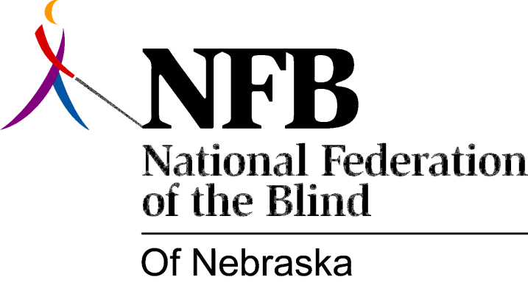

Resolution 1982 – 07
RE: Condemning John Knight for not appearing at the 1982 NFBN State Convention

WHEREAS, since the National Federation of the Blind of Nebraska is the largest organization of the blind in the State of Nebraska, it is imperative that the Governor’s Office interact with blind constituents on issues of concern to the blind; and,

WEREAS, this organization was led to believe that John Knight, Executive Director, Office of Human Services, Office of the Governor, would make an appearance at the 1982 convention of the NFB-N in Grand Island on Saturday, October 16th; and,

WEREAS, two hours prior to his scheduled appearance, John Knight “sent his regrets” with no explanation, in a note delivered to the President of the NFB-N by a hotel employee; now, therefore,

BE IT RESOVED, by the National Federation of the Blind of Nebraska, in Convention assembled this 17th day of October, 1982, in the city of Grand Island, Nebraska, that this organization condemn and deplore the token interest shown by the Governor’s Office in the affairs of the blind and this organization; and,

BE IT FURTHER RESOLVED, that the National Federation of the Blind of Nebraska express its’ concern and disappointment in John Knight’s last minute failure to appear at our 1982 State Convention; and,

BE IT FURTHER RESOLVED, that copies of this resolution be sent to the Governor Thones Office, John Knight and, other persons as designated by the President of this organization.

