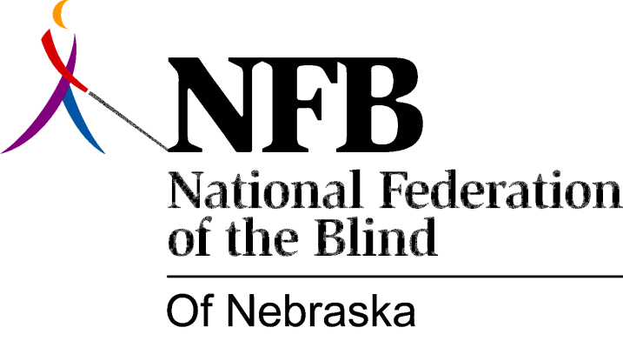

Resolution 1982 – 01
RE: Call for the Immediate Resignation of the Director of the Nebraska Equal Opportunity Commission

WHEREAS, the Nebraska Equal Opportunity Commission was established to protect the rights of specified “Protected Classes”, including the blind, with respect to employment, housing, and public accommodation; and,

WEREAS, in the past, Lawrence Myers, the Director of the N.E.O.C. failed to oversee and direct an investigation in the case of Laurie Eckery, a blind person, leading to discriminatory and incomplete results on the art of the Commission; and,

WEREAS, Mr. Myers is currently under investigation for various acts of irresponsibility by State and Federal Officials; now, therefore,

BE IT RESOLVED, the National Federation of the Blind of Nebraska, in Convention assembled, this 17th day of October, 1982, in the city of Grand Island, Nebraska, that the blind of Nebraska support the current investigation of the activities of Lawrence Myers; and,

BE IT FURTHER RESOLVED, that this organization demand the immediate resignation of Lawrence Myers; and,

BE IT FURTHER RESOLVED, that the Secretary of this organization be instructed to forward copies of this Resolution to;

- Governor Charles Thone
- Lawrence Myers
- Dan Wherry, Chairperson, Nebraska Equal Opportunity Commission
- Senator Chris Buetler
- And other persons designated by the President of this organization.

