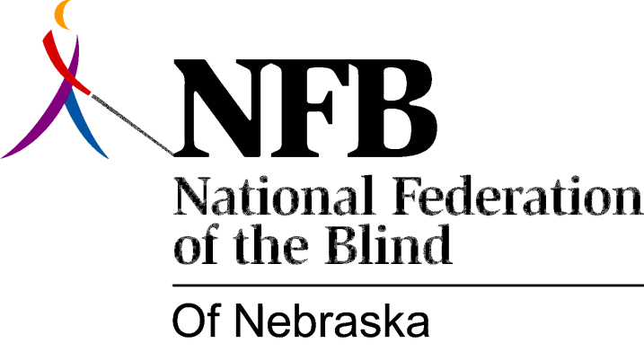

Resolution 1980 – 04
RE: Student Services Provided by the Nebraska Services for the Visually Impaired.

WHEREAS, there has been a lack of direction and clarity of duties regarding student services provided by the Nebraska Services for the Visually Impaired Program Administrator, Donovan Cooper; and,

WHEREAS, it is not uncommon for book orders produced on tape or in braille-whether ordered through or from SVI--to be delayed for long periods of time; and,

WHEREAS, students have been denied information regarding names and addresses of volunteer readers in the event that contact needs to be made with readers to expedite production of a book; and,

WHEREAS, at least one reader has been alienated due to lack of communication or understanding between the Program Administrator and the reader; and.

WHEREAS, all of these problems affect the quality of student services and cause unnecessary inconveniences for students receiving services; now, therefore,

BE IT RESOLVED, by the National Federation of the Blind of Nebraska, in convention assembled this seventh day of December, in the city of Lincoln, Nebraska, that the Director of SVI be strongly urged to set forth priority and clarify duties regarding student services as provided by the agency and the Program Administrator, and communicate these priorities and duties to the Student Division in a reasonable length of time at a meeting to be arranged by the Student Division’s president and the Director of SVI; and,

BE IT FURTHER RESOLVED, that the Director of SVI be urged to interact in a meaningful and effective manner with the elected leaders of the National Federation of the Blind of Nebraska's Student Division, or their designees, in the future.

