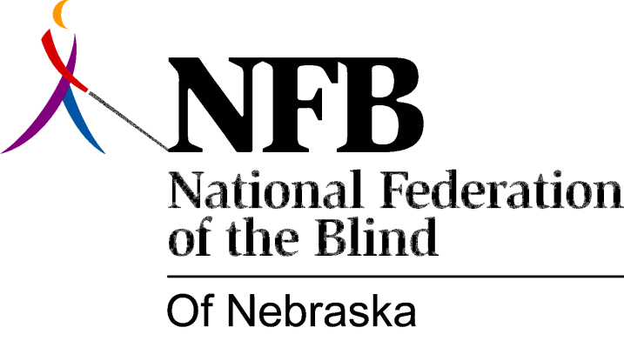

Resolution 1980 – 02
RE: Hike-A-Thon/Bike-A-Thon Donation to the National Treasury.

WHEREAS, the National Federation of the Blind is a national movement; and,

WHEREAS, we are attempting to establish hike-a-thons and bike-a-thons to be held on a single weekend with national sponsorship and national recognition; and,

WHEREAS, this coordinated effort on the part of all state affiliates will benefit blind persons throughout the country in ways which cannot be achieved at the state or local level; now, therefore,

BE IT RESOLVED, by the National Federation of the Blind of Nebraska, in convention assembled this sixth day of December, 1980, in the city of Lincoln, Nebraska, that the net proceeds of all future hike-a-thons or bike-a-thons sponsored by our state affiliate be contributed to our national treasury; and,

BE IT FURTHER RESOLVED, that the president of this organization be instructed to annually appoint a hike-a-thon/bike-a-thon committee which will work on site selection(s) and otherwise work with the national hike-a-thon/bike-a-thon committee on the coordination of this national project.

