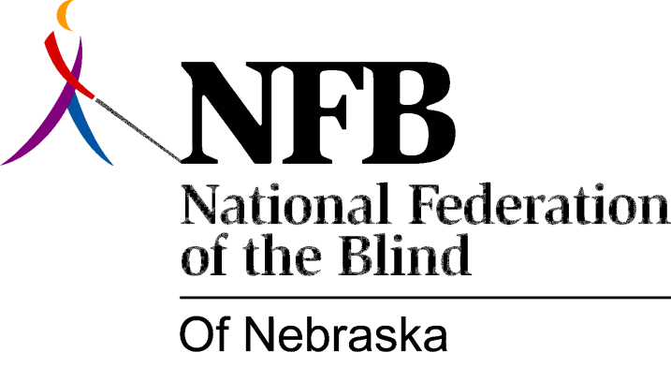

Resolution 1979 – 04
RE: Inappropriate Decision and Ineptness on the Part of the Nebraska Equal Employment Opportunity Commission

WHEREAS, the intent of legislation passed by the Unicameral in 1973 was to prohibit discrimination against the disabled in employment and,

WHEREAS, the rules and regulations of the Nebraska Equal Employment Opportunity Commission state: "The Commission shall institute an investigation by its employees to ascertain all of the facts relating to the alleged unfair employment practice or practices set forth in the charge. The staff shall initially solicit information from all parties and utilize interrogatories, depositions, or subpoenas to facilitate a prompt investigation." and,

WHEREAS, the Nebraska Equal Employment Opportunity Commission, on March 9, 1979, construed the law so narrowly as to ignore and defeat the letter and intent of the law in its decision in the case of Mrs. Lauren Eckery vs. Bishop Clarkson Memorial Hospital and,

WHEREAS, the March 9, 1979, decision of the Commission Board was based on an inept and inadequate investigation of the facts and evidence, not soliciting information from all parties, mainly Mrs. Lauren Eckery and the state of Nebraska Division of Rehabilitation Services for the Visually Impaired basing its decision exclusively on the prejudiced views of the personnel staff of Bishop Clarkson Hospital and,

WHEREAS, Bishop Clarkson Hospital did in fact admit that Mrs. Eckery was more qualified than her competition, all things considered, now, therefore,

BE IT RESOLVED, by the National Federation of the Blind of Nebraska, in convention assembled this 19th day of May, 1979, in the city of Hastings, Nebraska, that the Nebraska Equal Employment Opportunity Commission be strongly urged to adopt the practice of consulting the National Federation of the Blind of Nebraska in the future in all investigations of discrimination against the blind and,

BE IT FURTHER RESOVED, that a representative of the disabled selected from names submitted by organizations of the disabled, be appointed to the Commission Board and,

BE IT FURTHER RESOLVED, that the secretary of this organization be instructed to forward copies of this resolution to Mr. Lawerance Meyers, Executive Director of the Nebraska Equal Employment Opportunity Commission, the Chairperson of the Nebraska Equal Employment Opportunity Board, Governor Charles Thone and, appropriate Senators within the Unicameral.

Passed Unanimously

