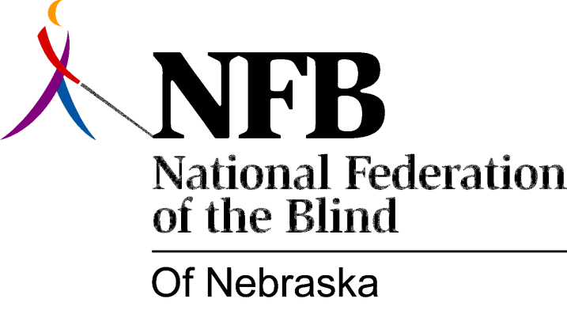

Resolution 1978 – 05
Re: Support for a State-Wide Radio Talking Book Service

WHEREAS, one of the major disadvantages of blindness is the lack of material readily available in a form usable by the print handicapped and

WHEREAS, Radio Talking Book Inc. airs material not otherwise easily available to the print handicapped (such as daily newspaper articles, shopping ads, and magazine articles) and

WHEREAS, Radio Talking Book Inc. provides information of special interest to the print handicapped and

WHEREAS, Radio Talking Book Inc. presents a positive view of blindness and

WHEREAS, Radio Talking Book Inc. can be used as a rehabilitation tool and

WHEREAS, this reading service is currently available only in the Lincoln and Omaha areas, now, therefore,

BE IT RESOLVED, by the National Federation of the Blind of Nebraska, in convention assembled this 18th day of June, 1978, in the city of Omaha, Nebraska, that this organization support the concept of a state-wide radio talking book service and

BE IT FURTHER RESOLVED, that this organization support any legislation acceptable to the State Board aimed at this purpose and

BE IT FURTHER RESOLVED, that the Secretary send copies of this resolution to the Nebraska Broadcasters Association, Nebraska Citizens for Public Radio and all appropriate public officials designated by the President.

Passed unanimously, June, 1978.

