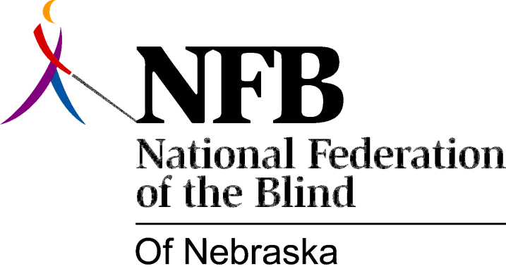

RESOLUTION 1977-09
RE: Improved Efforts by Nebraska Rehabilitation Services for the Visually Impaired to Develop and Expand the Business Enterprise Program.

WHEREAS, The Business Enterprise Program should be a viable and legitimate concern of Rehabilitation Services for the Blind; AND,

WHEREAS, There exists binding National Policy to this effect; AND,

WHEREAS, The Business Enterprise Program can be developed in such a way that would open occupational opportunities for Blind individuals in this state; AND,

WHERAS, The Division of Rehabilitation Services for the Visually Impaired has assumed an All too conservative posture in the provision of services which are conducive to the furtherance of this program in this state; NOW, THEREFORE,

BE IT RESOLVED, By the National Federation of the Blind of Nebraska in Convention assembled this15th day of Ma, 1977, in the city of Lincoln, Nebraska that the Division of Rehabilitation Services for the Visually Impaired be encouraged to take action which would indicate positive effort on its part to provide such services to develop and expand the business enterprise program into one which will provide blind individuals so inclined a more viable opportunity to engage in this occupational endeavor; AND,

BE IT FURTHER RESOLVED, That the secretary of this organization be instructed to send copies of this resolution to the director of the division of Rehabilitation services for the Visually Impaired and the President of Business Enterprise Vendors of Nebraska.

Passed Majority Vote May 15, 1977

