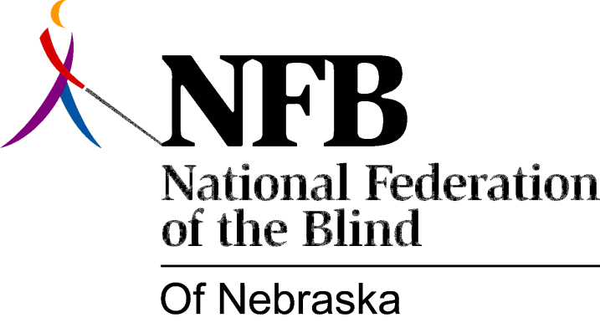

RESOLUTION 1977-08
RE: The Refusal of the Nebraska Library Commission and the Nebraska Library for the Blind and Physically Handicapped to Participate with Consumers of their Services.

WHEREAS, The National Federation of the Blind of Nebraska has demonstrated its interest in pursuing quality library services for the Blind of Nebraska and has worked with the Nebraska Library Commission and the Nebraska Library for the Blind and Physically Handicapped to achieve this goal; AND,

WHEREAS, The National Federation of the Blind of Nebraska invited a representative of the Nebraska Library for the Blind and Physically handicapped to inform us of services available and to discuss these services with us; AND,

WHEREAS, The Nebraska Library Commission and the Nebraska Library for the Blind and Physically Handicapped have refused to send a representative to the largest gathering of consumers of such library services -- The 1977 Annual Convention of the National Federation of the Blind of Nebraska; AND,

WHEREAS, The grounds stated for this refusal are that personnel will be moving materials and therefore cannot be responsive to its consumers; NOW, THEREFORE,

BE IT RESOLVED, By the National Federation of the Blind of Nebraska in Convention assembled this 14th Day of May, 1977, In the city of Lincoln, Nebraska that this organization condemns and deplores this refusal by the Nebraska Commission and the Nebraska Library for the Blind and Physically Handicapped to Disseminate information to its Library Patrons; AND,

BE IT FURTHER RESOVED, That the Secretary of this organization be instructed to send copies of this resolution to: John Kopischke, Director of the Nebraska Library Commission; all Commissioners of the Nebraska Library Commission; Frances Warnsholz, Head Librarian of the Nebraska Library for the Blind and Physically handicapped; Frank Kurt Cylke, Chief, Division for the Blind and Physically Handicapped, Library of Congress; and to all Pertinent and Concerned public officials.

Passed Unanimously May 14, 1977.

