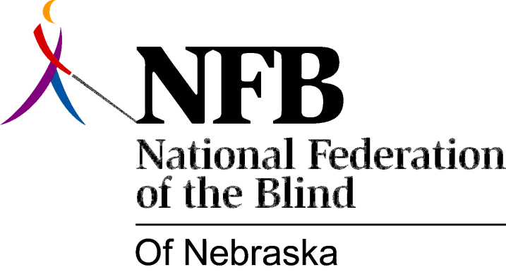

RESOLUTION 1977-07
RE: Condemnation of the Conduct of the Leaders of the Nebraska White House Conference on Handicapped Individuals.

WHEREAS, The Structure for the Nebraska White House Conference on Handicapped Individuals was rigidly imposed upon the delegates to that conference; AND,

WHEREAS, Suggestions by the delegates for more consumer input into the structure of the conference were looked upon as rebellion rather that as constructive criticism; AND,

WHEREAS, Most of the resolutions drafted by the individuals at the conference were not only poorly written, nonsensical in content, but also contrary to the binding policy held by the National Federation of the Blind; AND,

WHEREAS, The position papers submitted by the National Federation of the Blind of Nebraska were considered part of the "Minority Report" rather than being included alongside the resolutions; AND,

WHEREAS, The majority of those present at the conference favored a coalition of handicapped, NOW, THERFORE,

BE IT RESOLVED, By the National Federation of the Blind of Nebraska in convention assembled this 15th day of May, 1977, in the city of Lincoln, Nebraska that we condemn and deplore the conduct of the leaders of the Nebraska White House Conference on Handicapped Individuals for failing to respond favorably to the needs of the consumer, for failing to deal with the consumers position respectfully, and for considering most of the position papers submitted by the National Federation of the Blind of Nebraska as less than priority contributions to the conference, AND,

BE IT FURTHER RESOLVED, That this organization make it clear to the leadership of that conference that we cannot, and will not support coalitions of the Handicapped which include the Blind; AND,

BE IT FURTHER RESOLVED, That the secretary of this organization shall be instructed to send copies of this resolution to Jack Smith, Executive Director of the National White House Conference on Handicapped Individuals and to Larry Nedrow, Director of the Nebraska White House Conference on Handicapped Individuals.

Passed Unanimously May 15, 1977

